Microsoft Azure - Starter Kits for Partners

Hands on Lab

Application Servers Scenario

With HA & Auto Scaling

(Classic Mode)

Last Update: September 2015





**MICROSOFT MAKES NO WARRANTIES, EXPRESS, IMPLIED OR STATUTORY, AS TO THE INFORMATION IN THIS DOCUMENT.**

The information contained in this document represents the current view of Microsoft Corporation on the issues discussed as of the date of publication. Because Microsoft must respond to changing market conditions, it should not be interpreted to be a commitment on the part of Microsoft, and Microsoft cannot guarantee the accuracy of any information presented after the date of publication.

Complying with all applicable copyright laws is the responsibility of the user. Without limiting the rights under copyright, no part of this document may be reproduced, stored in or introduced into a retrieval system, or transmitted in any form or by any means (electronic, mechanical, photocopying, recording, or otherwise), or for any purpose, without the express written permission of Microsoft Corporation.

Microsoft may have patents, patent applications, trademarks, copyrights, or other intellectual property rights covering subject matter in this document. Except as expressly provided in any written license agreement from Microsoft, the furnishing of this document does not give you any license to these patents, trademarks, copyrights, or other intellectual property.

The descriptions of other companies’ products in this document, if any, are provided only as a convenience to you. Any such references should not be considered an endorsement or support by Microsoft. Microsoft cannot guarantee their accuracy, and the products may change over time. Also, the descriptions are intended as brief highlights to aid understanding, rather than as thorough coverage. For authoritative descriptions of these products, please consult their respective manufacturers.

© 2014 Microsoft Corporation. All rights reserved. Any use or distribution of these materials without express authorization of Microsoft Corp. is strictly prohibited.

Microsoft and Windows are either registered trademarks of Microsoft Corporation in the United States and/or other countries.

The names of actual companies and products mentioned herein may be the trademarks of their respective owners.

Contents

Overview 4

Objectives 4

Prerequisites 4

Exercises 5

Infrastructure Provisioning 5

Exercise 1: Creating the Virtual Network 5

Exercise 2: Creating the Storage Account 7

Exercise 3: Creating Virtual Machines for IIS 8

Exercise 4: Creating the Domain Controller Virtual Machines 32

Exercise 5: Creating SQL Server Virtual Machines 48

Exercise 6: Deploying a Simple MVC4 Application - Manually 110

Exercise 7: Provisioning Automation with Custom Images and PowerShell 117

Exercise 8: Enabling Auto Scaling 122

Summary 125

Additional References: 125

## Overview

Using Microsoft Azure, as your Infrastructure as a Service (IaaS) platform, will enable you to create and manage your infrastructure quickly, provisioning and accessing any host ubiquitously. Grow your business through the cloud-based infrastructure, reducing the costs of licensing, provisioning and backup.

In this hands-on Lab, you will learn how to deploy a simple ASP.NET MVC 4 Web application to a Web Farm hosted in Microsoft Azure IaaS, using SQL Server Always On and configuring load balancing/auto scaling.

**Estimated time** to complete this lab: **180 minutes**.

**Audience**: IT Pro, Architect, Application Owners and Developers

### Objectives

In this hands-on lab, you will learn how to:

* Create a Virtual Network with and Subnets
* Create a Web Farm (IIS) using Microsoft Azure Management Portal
* Configure Load Balancing for Web Farm
* Create Domain Controller Virtual Machines
* Create Virtual Machines with SQL Server
  + Enable Full-Text Search feature to be consumed by the MVC Application
  + Configure SQL Server to use Always On
* Deploy a Simple MVC4 Application that consumes SQL Server Features
* Automate provisioning with PowerShell
* Configure Auto Scaling

The Hands On covers the following Architecture:

### Prerequisites

The following is required to complete this hands-on lab:

* A Microsoft Azure subscription - [sign up for a free trial](http://aka.ms/WATK-FreeTrial)
* [Azure PowerShell 0.7.4](http://go.microsoft.com/fwlink/p/?linkid=320376)  or higher
* [Windows PowerShell 3.0](http://go.microsoft.com/fwlink/p/?LinkId=393708) or higher



## Exercises

## Infrastructure Provisioning

### Exercise 1: Creating the Virtual Network

In this exercise, you will learn how to create a Virtual Network in Microsoft Azure.

#### Task 1 – Create Virtual Network

In this task, you will create a Cloud-Only Virtual Network in the Management Portal. When you create a virtual network, your services and VMs within the VNet can communicate securely with each other without having to go out through the Internet. Creating a dedicated cloud-only virtual network is a relatively fast and easy process. Because a cloud-only virtual network isn’t intended for cross-premises connectivity, you won’t need to acquire and configure a VPN device or authentication certificates.

1. Log in to the **Microsoft Azure Management Portal**.
2. In the lower left-hand corner of the screen, click **New**. In the navigation pane, click **Network Services**, and then click **Virtual Network**. Click **Custom Create** to begin the configuration wizard.
3. On the **Virtual Network Details** page, enter the information below:

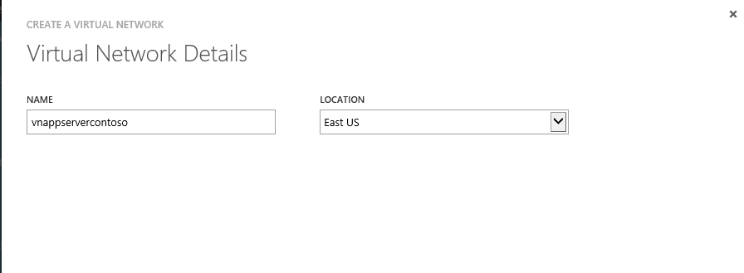

1. On the **DNS Servers and VPN Connectivity** page, don’t make any changes. Just move forward to the next page by clicking the arrow. By default, Azure provides basic name resolution for your virtual network. It’s possible that your name resolution requirements are more complex than can be handled by the basic Azure name resolution. In that case, you may later want to add a virtual machine running DNS to your virtual network.
2. The **Virtual Network Address Spaces** page is where you enter the address space that you want to use for this VNet.
3. Create the following subnets:

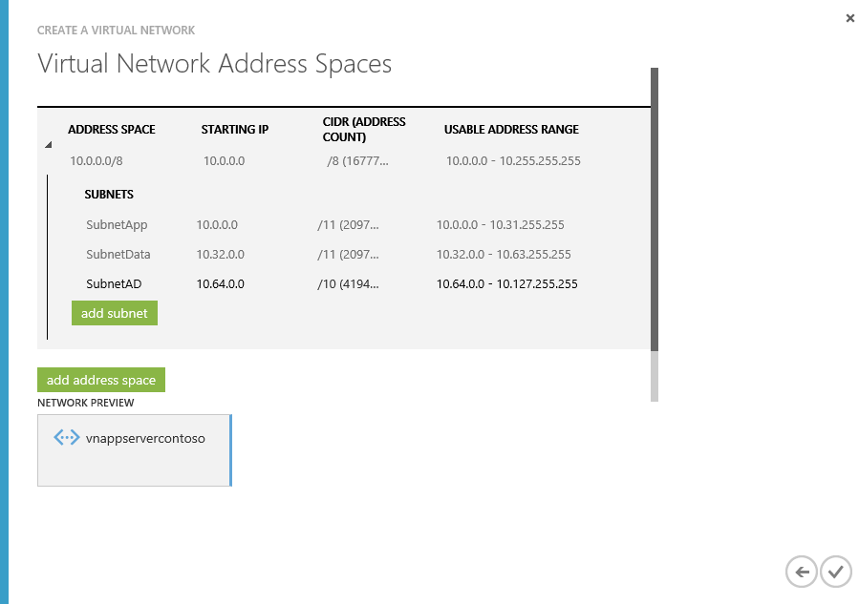

1. Click the checkmark on the lower right of the Virtual Network Address Spaces page and your virtual network will begin to create. When your virtual network has been created, you will see **Created** listed under **Status** on the **networks** page in the Management Portal.

### Exercise 2: Creating the Storage Account

* 1. In this exercise, you will learn how to create a Storage Account.

1. Log in to the **Microsoft Azure Management Portal**.
2. Click Create New, click Storage, and then click Quick Create.
3. In URL, enter a subdomain name to use in the storage account URL.
4. In Region, select a region for the storage. For this exercise select the previously created.
5. If you have more than one Azure subscription, then the Subscription field is displayed. In Subscription, enter the Azure subscription that you want to use the storage account with. You can create up to five storage accounts for a subscription.
6. In Replication, select the level of replication that you desire for your storage account. For this exercise, select Locally Redundant. *Locally redundant storage (LRS)* maintains three copies of your data. LRS is replicated three times within a single facility in a single region.
7. Your storage account should be similar to:
   1. 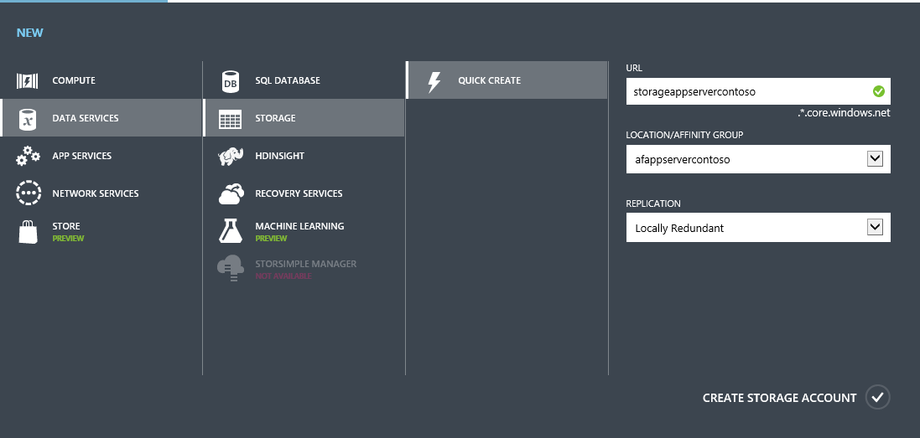

### Exercise 3: Creating Virtual Machines for IIS

In this exercise, you will learn how to create a Virtual Machine in Microsoft Azure. Then, you will configure an Internet Information Server adding roles to use later on in this lab.

Note: For this exercise, we are not considering the IIS VMs to be domain-joined, you are free to join them to the domain after exercise 4.

#### Task 1 - Creating IIS Virtual Machines

In this task, you will provision a Virtual Machine and configure the Load Balancing to host an MVC4 application.

1. Open Internet Explorer and browse to <https://manage.windowsazure.com/> to enter the Microsoft Azure portal. Then, log in with your credentials.
2. In the menu located at the bottom, select **New | Compute | Virtual Machine | From Gallery** to start creating a new virtual machine.

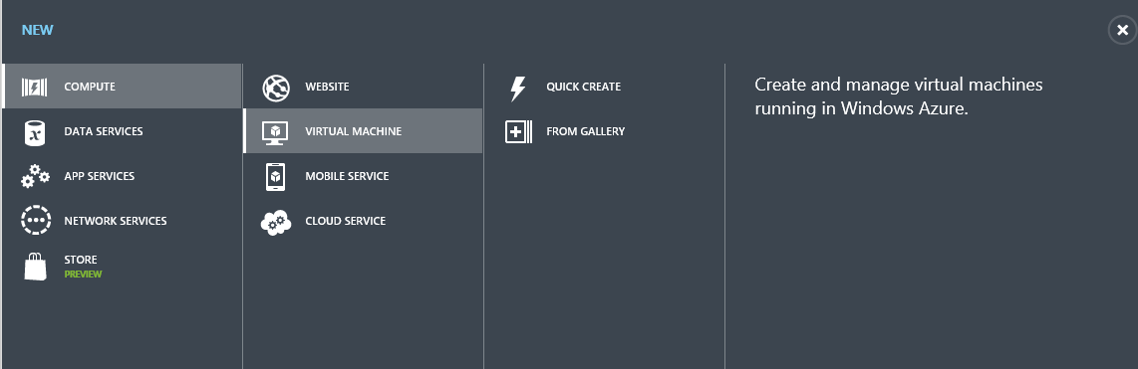

Creating a new Virtual Machine

1. In the **Virtual Machine OS Selection** page, click **Platform Images** on the left menu and select the **Windows Server 2012 R2 Datacenter** OS image from the list. Click the arrow to continue.
2. In the **Virtual Machine Configuration** page, leave the version release date by default (latest). Enter the Virtual Machine Name (i.e. "iisvm1"), provide a user name for the **New User Name** field and a password for the **New Password** and **Confirm Password** fields. This password needs to contain three of these – lower case characters, uppercase characters, numbers and special characters. Make sure you remember your choice. Lastly, set the Virtual Machine **Size** to **A2** and click **Next** to continue.

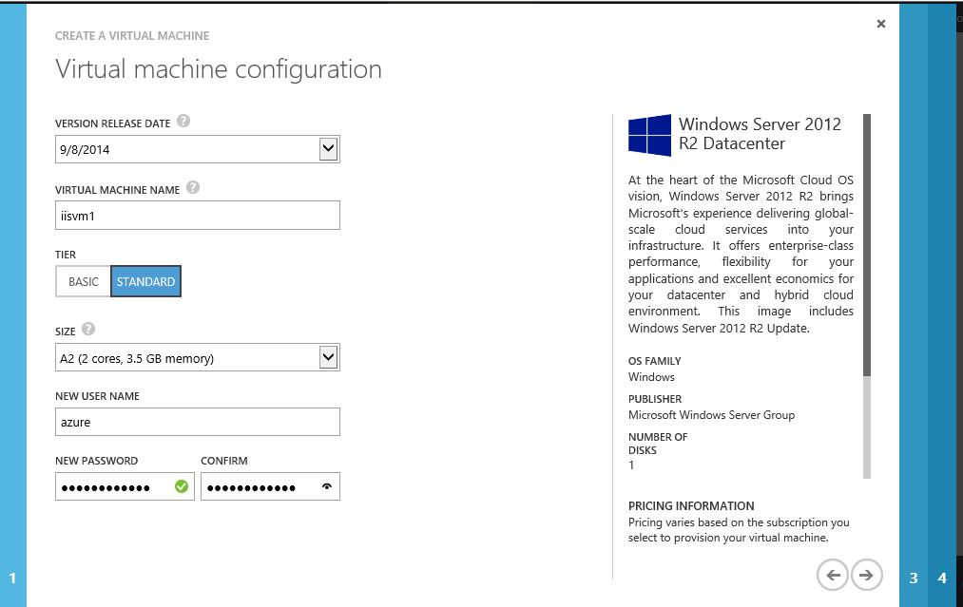

Creating a Virtual Machine - Configuration

**Note:** It is suggested to use secure passwords for admin users, as Microsoft Azure virtual machines could be accessible from the Internet knowing just their DNS.

You can also read this document on the Microsoft Security website that will help you select a secure password: <http://www.microsoft.com/security/online-privacy/passwords-create.aspx>

1. In the **CREATE a** **Virtual Machine Mode** page, select **Storage Account created in the previous steps**.
   1. For **Cloud Service** select **create a new cloud Service** and then in the **Cloud Service Name** provide a name for your cloud Service.
   2. On the **Region/Affinity group/Virtual network** select the **Virtual Network** created on Exercise 1
   3. For **Virtual network subnets**, select **SubNetApp**
   4. On the **Availability Set**, make sure to select **Create an Availability Set**, and then name it as “**avsetapp”**.
   5. Click the **right arrow** to continue

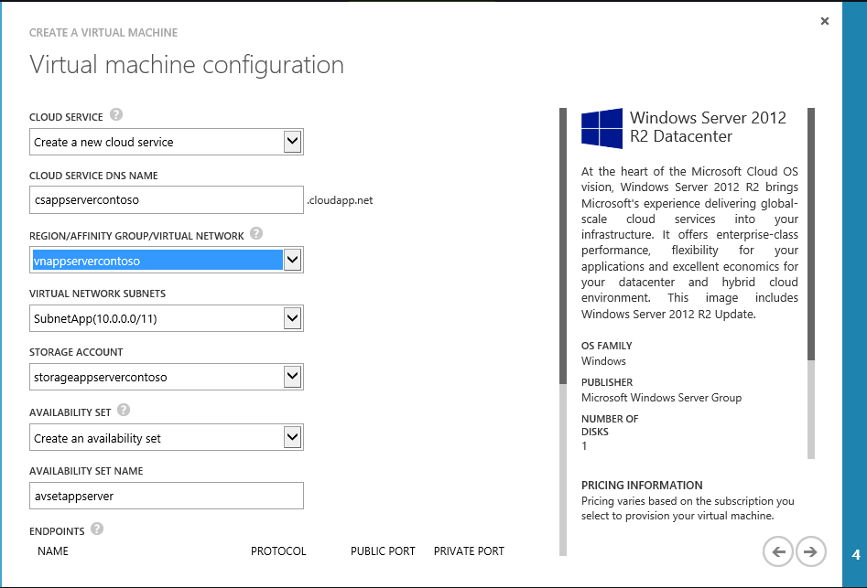

1. On the next screen, maintain the default option, click the **check mark** to continue

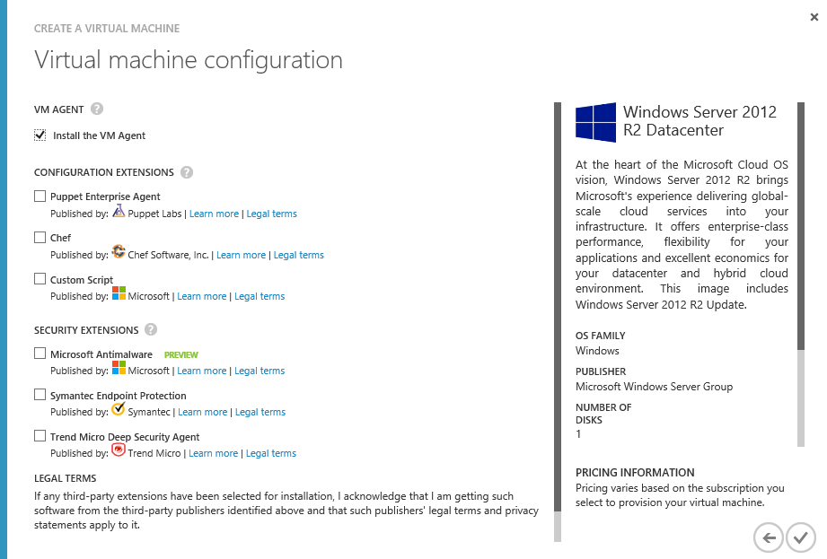

1. In the **Virtual Machines** section, you will see the Virtual Machine you created with a Starting (provisioning) status. Wait until it changes to Running in order to continue with the following step as you will need a provisioned Virtual Machine on the following steps.

[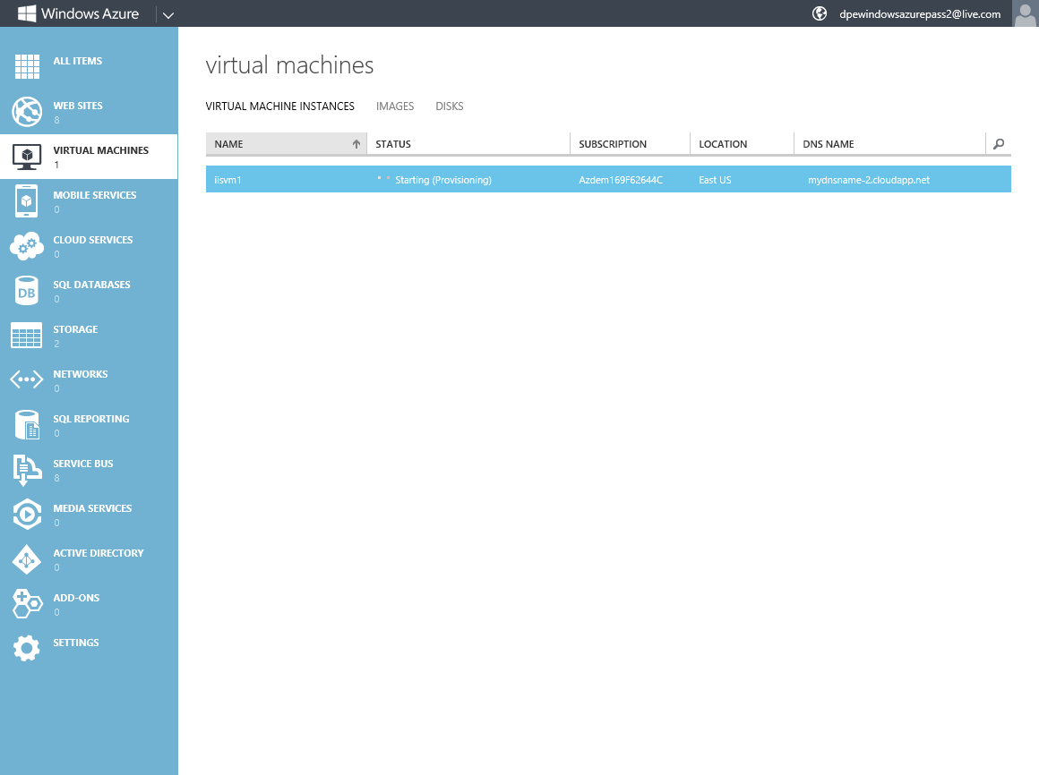](https://github.com/WindowsAzure-TrainingKit/HOL-IntroToWindowsAzureVirtualMachines/blob/master/Images/creating-vm-for-iis-web-farm.png?raw=true)

Creating Virtual Machine for IIS Web Farm

**Note:** It will take from 5 to 10 minutes for the Virtual Machine to complete the provisioning process.

1. You will now add the second Virtual Machine for the IIS Load Balancing. In the portal, select **New | Compute | Virtual Machine | From Gallery**.
2. In the **Virtual Machine OS Selection** page, click **Platform Images** on the left menu and select the **Windows Server 2012 R2 Datacenter,** OS image from the list. Click the **arrow** to continue.
3. In the **Virtual Machine Configuration** page, enter the **Virtual Machine Name** (i.e. "iisvm2"), a **User Name**, a **Password** and the **Size**. Click the **right arrow** to continue.
4. In the **Create a Virtual Machine** page, select **Cloud Service** and choose the first **cloud service** you created from the drop down list. Select the same **StorageAccount, Virtual Network, Availability Set** for the Virtual Machine created in the previous step. This step adds the new virtual machine to the cloud service created in the previous step. This allows the virtual machines to be on the same network.

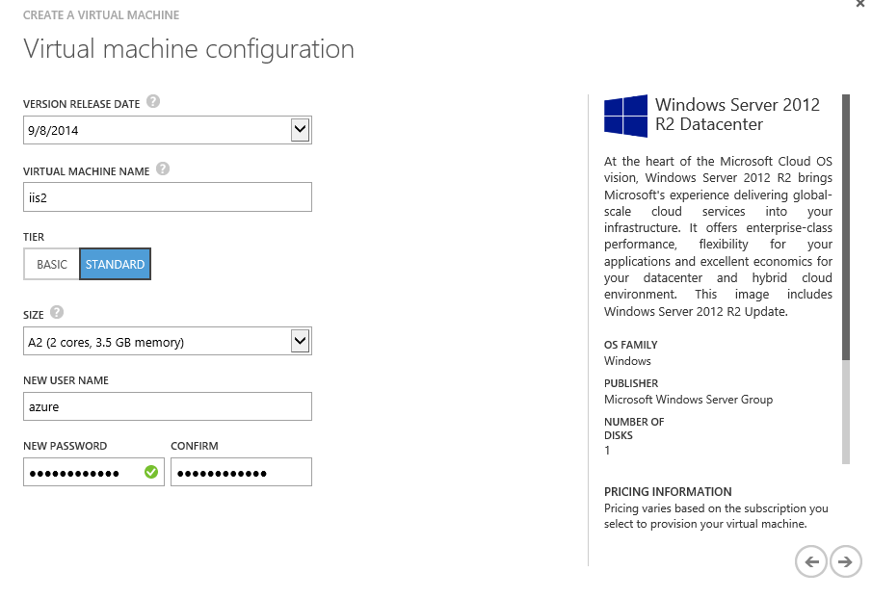

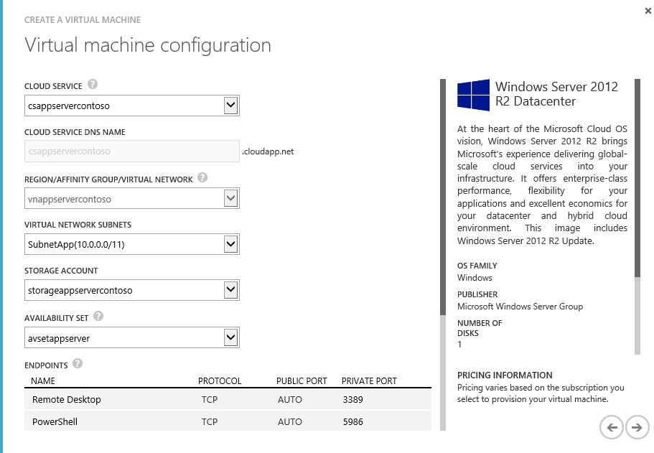

Creating a Virtual Machine - Virtual Machine Mode

1. In the **Virtual Machine Options** page, leave the default values and click the button to create a new Virtual Machine.
2. Wait until the second Virtual Machine is created. You can check the Virtual Machine status from the Virtual Machines section within the portal.

**Note:** It will take from 5 to 10 minutes for the virtual machine to complete the provisioning process.

1. After creating the second virtual machine, you will create an endpoint in the port 80 in the Virtual Machine you created first. To do this, click on the first Virtual Machine Name (iisvm1) to go to the **Dashboard** page and then click **Endpoints**. Click **Add Endpoint** on the bottom pane.

[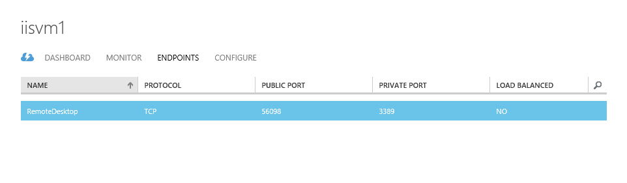](https://github.com/WindowsAzure-TrainingKit/HOL-IntroToWindowsAzureVirtualMachines/blob/master/Images/adding-a-new-endpoint-dashboard.png?raw=true)

Selecting Add Endpoint in the dashboard

1. Make sure that **Add Endpoint** option is selected and then click the **right arrow** button to continue.

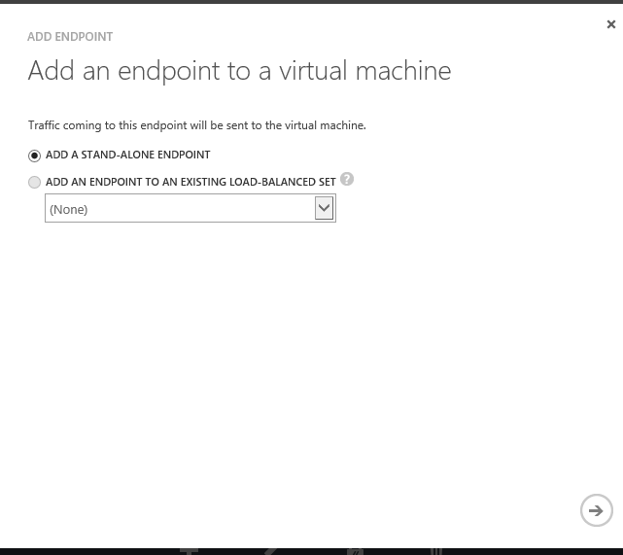

Adding a new Endpoint

1. In the **Specify endpoint details** page, set the **Name** to webport, the **Protocol** to TCP and the **Public Port** and **Private Port** to 80. Click the button to create the endpoint. Wait until the Endpoint is created before continue to the following steps.

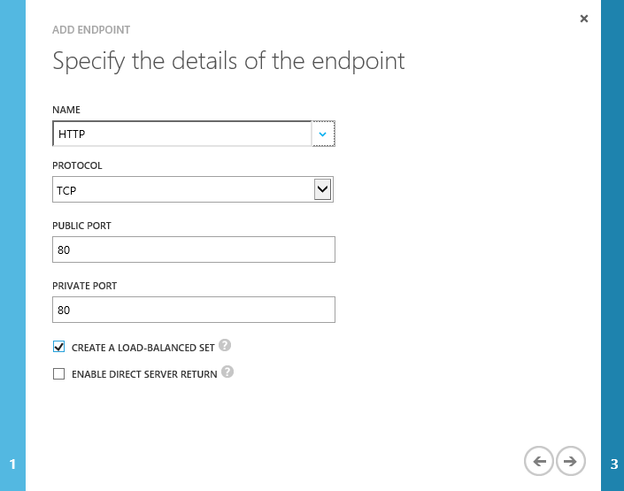

New Endpoint Details

1. In the Configure the Configure the **load-balanced** set, input the following and click on

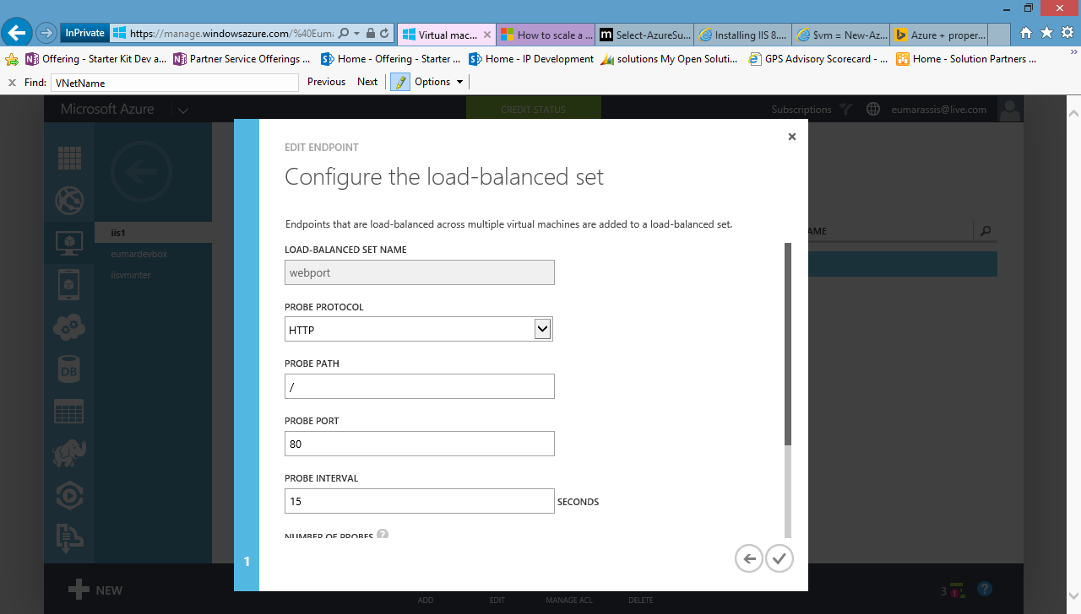

**Note:** It will take some minutes to create a new endpoint. **Wait to finish before going to the next step**

1. Now, create a new Endpoint in the second Virtual Machine in order to enable Load Balancing between both Virtual Machines. To do this, click **Virtual Machines** and then select the second Virtual Machine you created. Then, click **Endpoints**.
2. Click **Add Endpoint**, select **Add An Endpoint to an Existing Load-Balanced Set** option. Select the endpoint you created for the first Virtual Machine from the drop down list and then click the **right arrow** to continue.

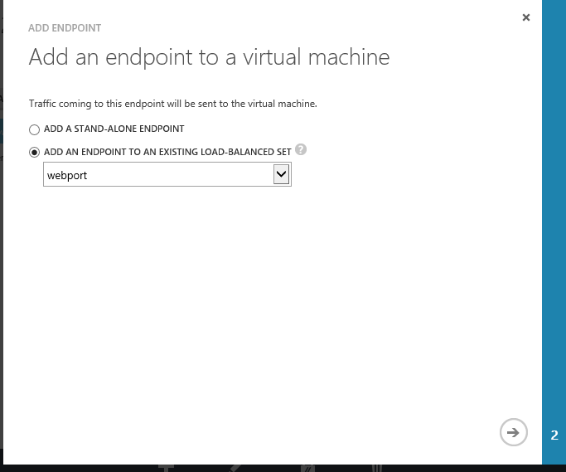

Load Balance Traffic On An Existing Endpoint

1. In the **New Endpoint Details** page, set the **Name** to webport and the **Private Port** to 80. Click the button to create the endpoint.

**Note:** It will take some minutes to create a new endpoint.

1. In the **Virtual Machines** section, click on the first Virtual Machine Name (iisvm1) and then click **Endpoints**.
2. Select the **webport** endpoint you have created. Make sure the **Load Balancer** column value is **Yes**.

[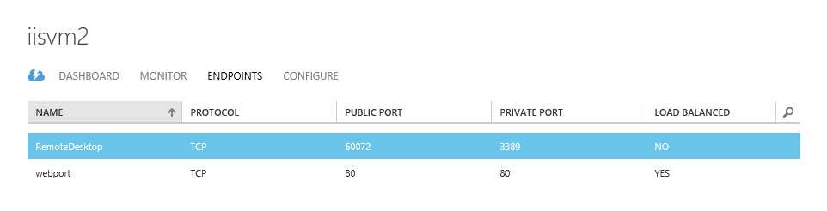](https://github.com/WindowsAzure-TrainingKit/HOL-IntroToWindowsAzureVirtualMachines/blob/master/Images/creating-load-balancing-endpoint-1.png?raw=true)

Verification: enabling IIS Load Balancing

1. Click the **Edit Endpoint** button in the bottom bar to enter the endpoint details and verify the load balancing is enabled. Repeat this step in the second Virtual Machine.

[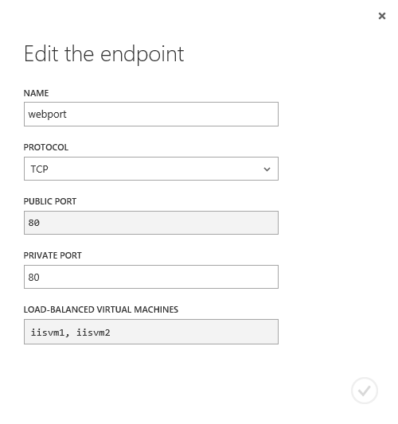](https://github.com/WindowsAzure-TrainingKit/HOL-IntroToWindowsAzureVirtualMachines/blob/master/Images/creating-load-balancing-endpoint-2.png?raw=true)

Verification: enabling IIS Load Balancing, details

#### Task 2 - Configuring IIS Virtual Machines

In this task, you will configure the IIS Virtual Machines by adding the necessary roles to deploy the MVC application.

1. In the Portal, click **Virtual Machines** on the left menu.
2. You will see a list with your existing Virtual Machines. Select the first one you created in Task 1 and click the **Connect** button in the bottom bar. If you used the proposed name, this Virtual Machine should be named **iisvm1**.
3. You will be asked to download the remote desktop settings file. Click **Open** and log on using the credentials you defined when creating the Virtual Machine.

When the Web Server (UI) role is chosen for the first time in the **Add Roles and Features Wizard** in Server Manager, the basic components and services needed for IIS are automatically selected. The following procedure will install Internet Information Services on a running server when IIS has not already been installed. To change an existing installation of IIS, perform the next procedure, Install additional role services for IIS.

1. Open Server Manager by clicking the **Server Manager** icon on the desktop.
2. In the **Server Manager** window, with the **Dashboard** and **Quick Start** selected, click **Add roles and features**, or click the **Manage** menu, and then click **Add Roles and Features**.
3. On the **Before You Begin** page, click **Next**.
4. On the **Installation Type** page, select **Role-based or feature-based installation** to configure a single server. Click **Next**.

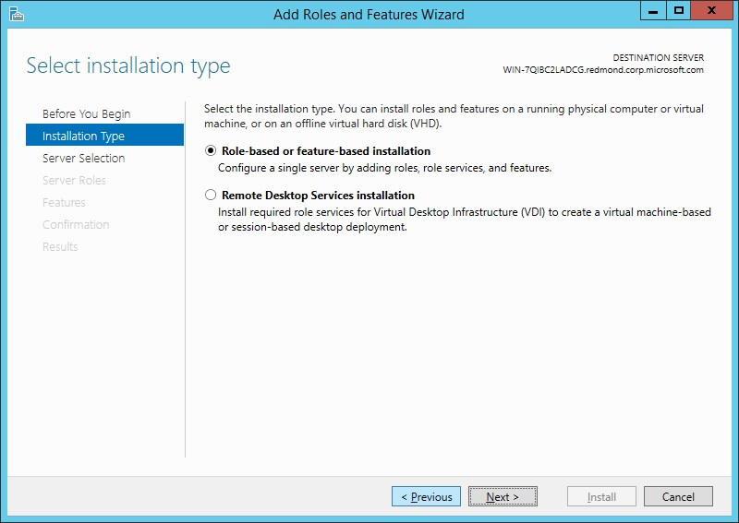

1. On the **Server Selection** page, select **Select a server from the server pool**, and then select a server; or select **Select a virtual hard disk server**, select a server to mount the VHD on, and then select a VHD file. Click **Next**.

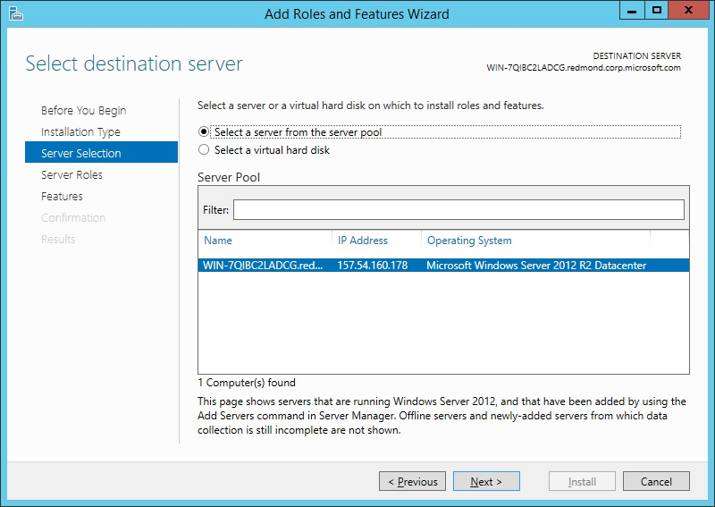

1. On the **Server Roles** page, select **Web Server (IIS) and Application Server**.

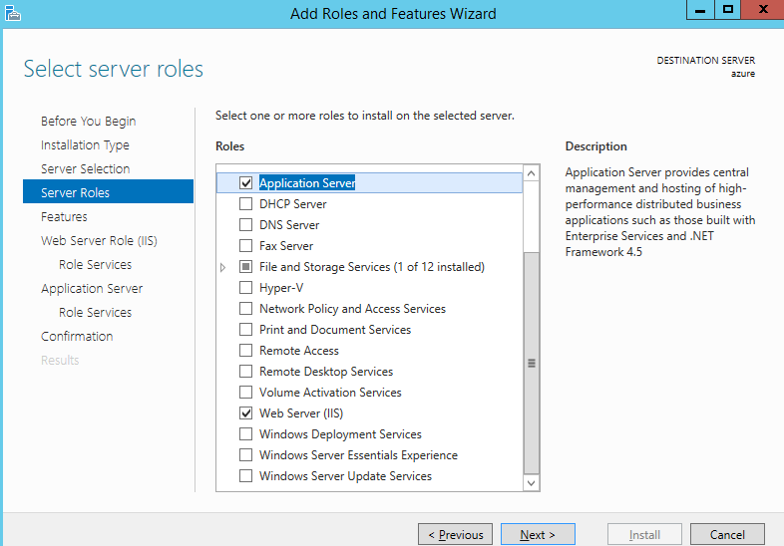

1. In the **Add Roles and Features** wizard, Web Server Role (IIS), Role Services, select IIS **Management Console**..
2. 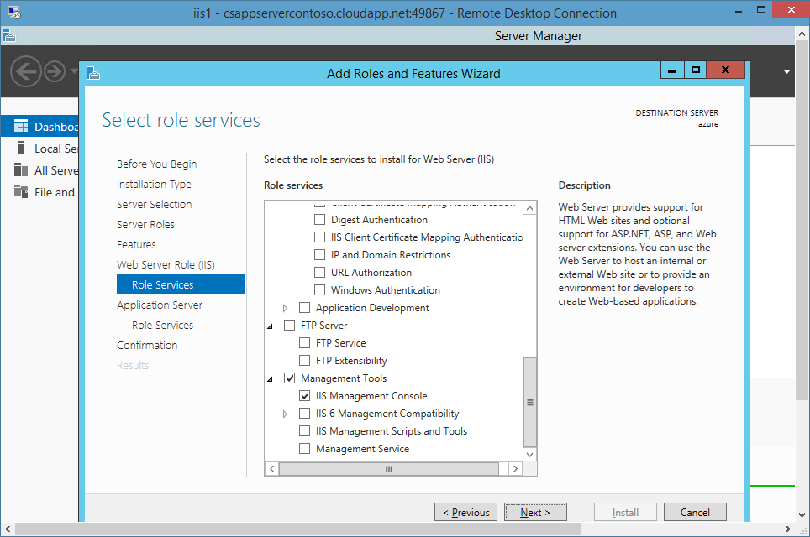
3. On the Application Server > Roles Services select **Web Server (IIS) Support**

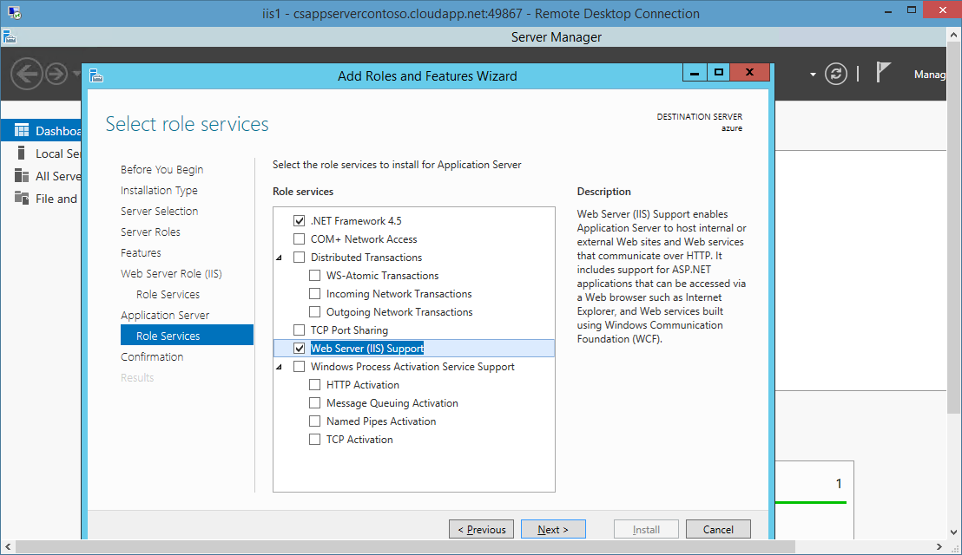

1. 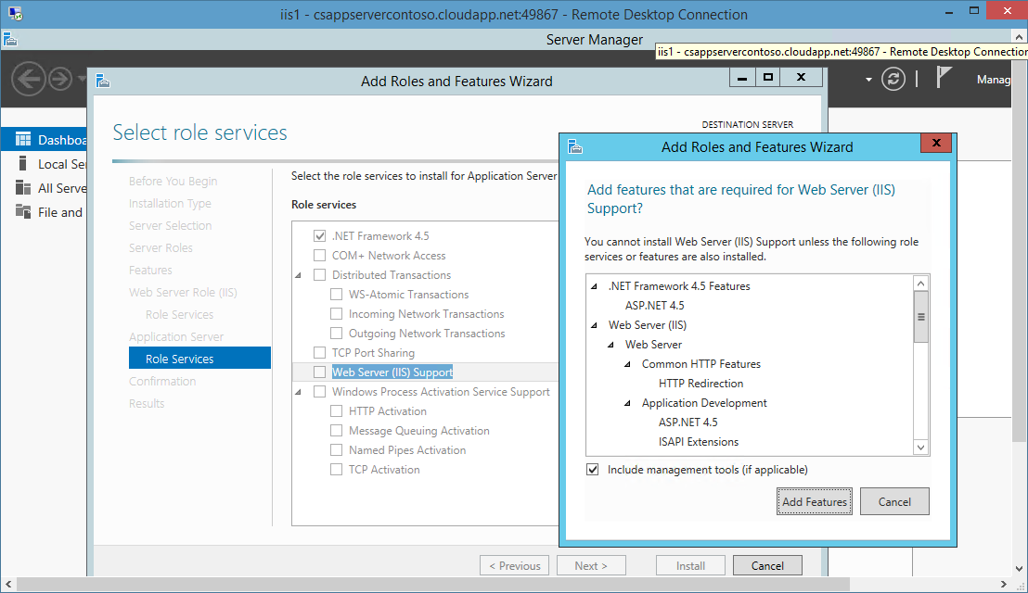
2. On the **Confirmation** page, verify the role services and features that are selected. Select **Restart the destination server automatically if required** to restart the destination server if the settings need to take immediate effect.

When you are ready to start the installation process on the **Confirmation** page, click **Install**.

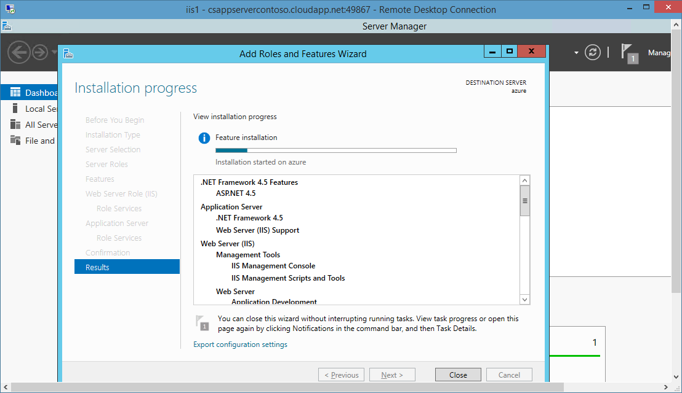

1. The **Installation Progress** page is displayed. You can close the wizard without interrupting running tasks. You can view task progress or open the page again by clicking **Notifications** in the notification area, and then clicking **Task Details**.

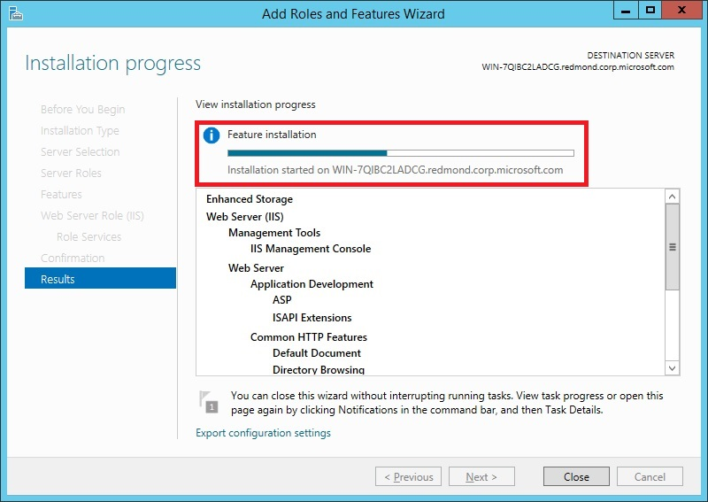

1. On the **Results** page, verify that the installation succeeds, and then click **Close**.
2. Confirm that the Web server works by opening a Web browser, and verifying that the following default Web page is displayed when you use the http://localhost address.

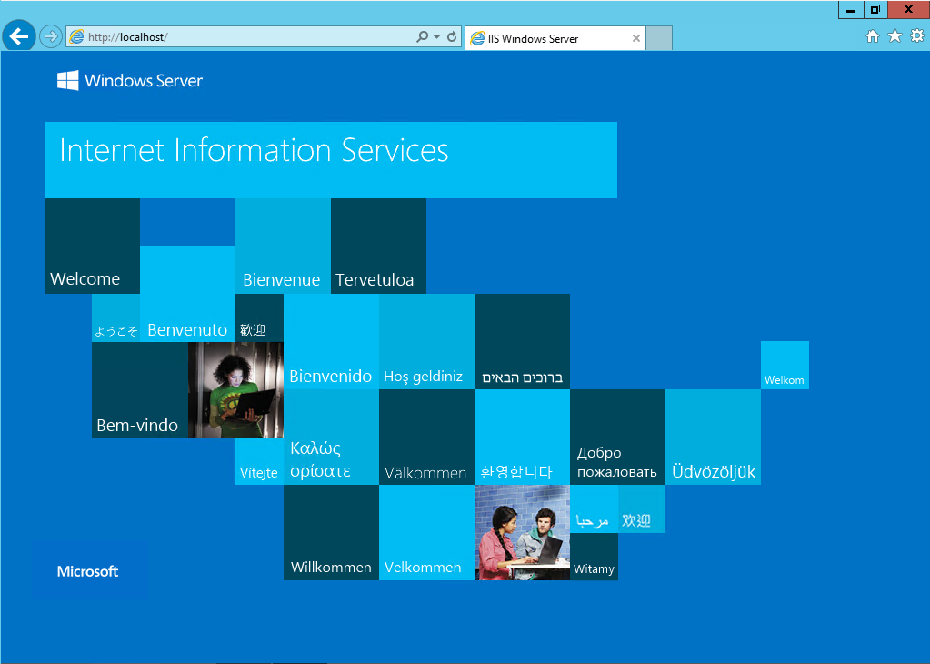

1. Close the **Remote Desktop Connection**.

Repeat this task on the second Virtual Machine to install IIS, starting from step 4. If you used the proposed name, the second Virtual Machine should be named **iisvm2**.

.

### Exercise 4: Creating the Domain Controller Virtual Machines

#### Task 1: Create a VM to run the domain controller and DNS server roles

1. Click **New** > **Compute** > **Virtual Machine** > **From Gallery**.
2. Use the values in the following table to complete the wizard.

| On this wizard page… | Specify these values |
| --- | --- |
| **Operating system** | Select **Windows Server 2012 R2 Datacenter** |
| **Virtual machine configuration** | **Release date**: Today's date  **Machine name:** Specify a unique value  **Tier**: Standard  **Size**: **A2 - Small**  **User name**: Enter a name. This user account will be a member of the built-in Administrators group.  **Password**: Must be at least 8 characters, and include 3 of the following types of characters:   * + an uppercase letter   + a lowercase letter   + a number   + a special character |
| **Cloud service** | **Storage Account**: the one created in the previous steps.  **Cloud Service**: select create a new cloud Service and then in the Cloud Service Name provide a name for your cloud Service.  **Region/Affinity group/Virtual network**: select the Virtual Network created on Exercise 1  **Virtual network subnets**: select SubnetAD    Availability set: **avsetad -** make sure to select Create an Availability Set, and then name it as “avsetaad”.  Endpoints: Accept default values |
| **VM Agent** | Select **Install the VM Agent** |

1. The dynamic IP address that the VM is assigned by default is valid for the duration of the cloud service. But it will change if the VM is shut down. Assign a static IP address by [running the Set-AzureStaticVNetIP Azure PowerShell cmdlet](http://msdn.microsoft.com/en-us/library/windowsazure/dn630228.aspx) so the IP address will persist if you ever do need to shut down the VM. E.g.

Test-AzureStaticVNetIP –VNetName $VNET$ –IPAddress 10.64.0.4

Get-AzureVM -ServiceName $CLOUDSERVICE$ -Name $VM$ | Set-AzureStaticVNetIP -IPAddress 10.64.0.4| Update-AzureVM

1. Attach an additional disk to the VM to store the Active Directory database, logs, and SYSVOL.
   * Click the **VM** > **Attach** > **Attach empty disk**.
   * Specify a size (for example, 10 GB) and accept all other default values.
2. Log on to the VM and format the additional disk.
   * Click **Connect** to log on to the VM, click **Open** to create an RDP session, and click **Connect** again.
   * Change the credentials to the new user name and password you specified.
   * In Server Manager, click **Tools** > **Computer Management**.
   * Click **Disk Management** and click **Ok** to initialize the new disk.
   * Right-click the disk name and click **New Simple Volume**. Complete wizard to format the new drive.

#### Task 2: Install Windows Server Active Directory

[Install AD DS](http://technet.microsoft.com/library/jj574166.aspx) by using the same routine that you use on-premises (that is, you can use the UI, an answer file, or Windows PowerShell). You need to provide Administrator credentials to install a new forest. To specify the location for the Active Directory database, logs, and SYSVOL, change the default storage location from the operating system drive to the additional data disk that you attached to the VM.

This section explains how to install the first domain controller in a forest root domain using Server Manager on a graphical Windows Server 2012 computer.

##### Server Manager AD DS Role Installation Process

The diagram below illustrates the Active Directory Domain Services role installation process, beginning with you running ServerManager.exe and ending right before the promotion of the domain controller.

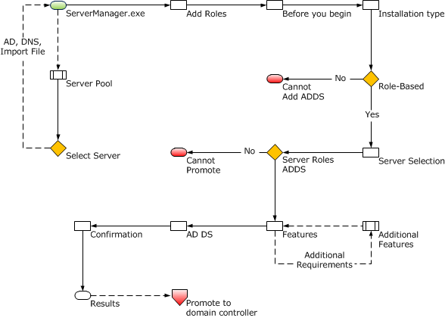Server Pool and Add Roles

Any Windows Server 2012 computers accessible from the computer running Server Manager are eligible for pooling. Once pooled, you select those servers for remote installation of AD DS or any other configuration options possible within Server Manager.

The computer you are running Server Manager on pools itself automatically. To install the AD DS role here, simply click the **Local Server** > **Manage** menu and click **Add Roles and Features**.

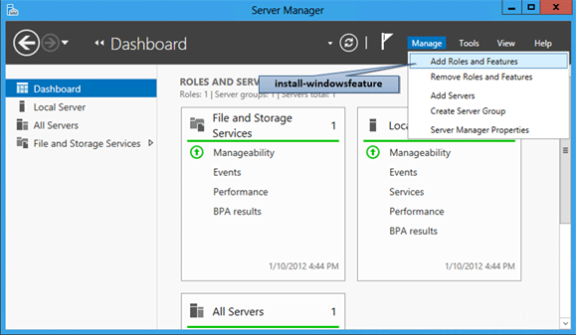

##### Installation Type

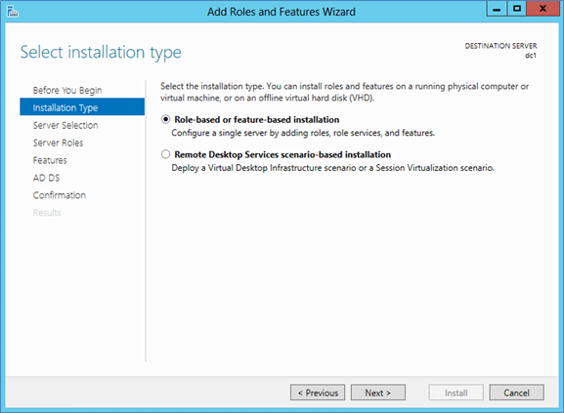

The **Installation Type** dialog provides an option that does not support Active Directory Domain Services: the **Remote Desktop Services scenario based-installation**. That option only allows Remote Desktop Service in a multi-server distributed workload. If you select it, AD DS cannot install.

Always leave the default selection in place when installing AD DS: **Role-based or Feature-based Installation**.

##### [Server Selection](javascript:void(0))

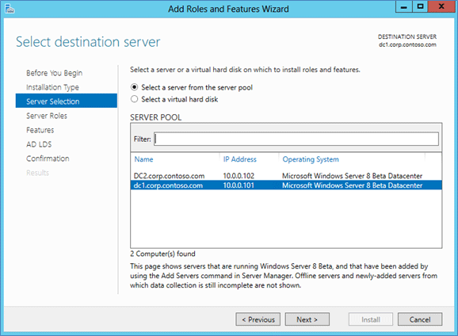

The **Server Selection** dialog enables you to choose from one of the servers previously added to the pool, as long as it is accessible. The local server running Server Manager is automatically available.

In addition, you can select offline Hyper-V VHD files with the Windows Server 2012 operating system and Server Manager adds the role to them directly through component servicing. This allows you to provision virtual servers with the necessary components before further configuring them.

##### [Server Roles and Features](javascript:void(0))

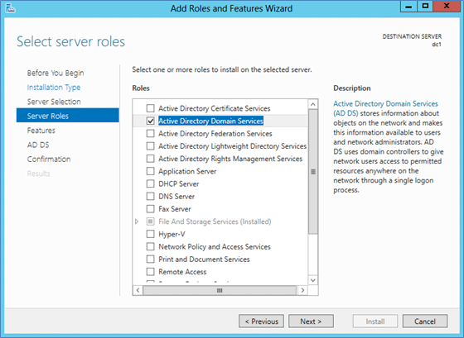

Select the **Active Directory Domain Services** role if you intend to promote a domain controller. All Active Directory administration features and required services install automatically, even if they are ostensibly part of another role or do not appear selected in the Server Manager interface.

Server Manager also presents an informational dialog that shows which management features this role implicitly installs; this is equivalent to the **-IncludeManagementTools** argument.

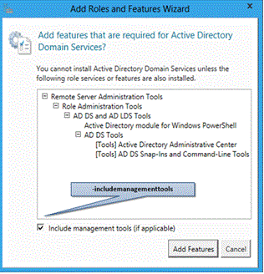

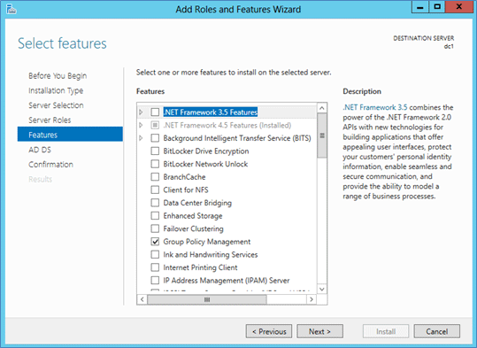

Additional **Features** can be added here as desired.

##### [Active Directory Domain Services](javascript:void(0))

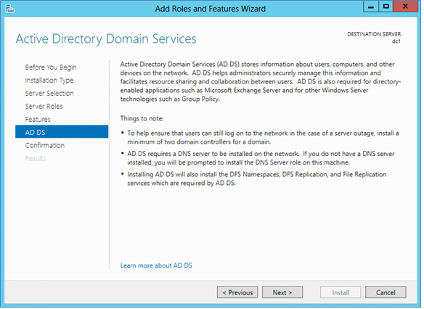

The **Active Directory Domain Services** dialog provides limited information on requirements and best practices. It mainly acts as a confirmation that you chose the AD DS role – if this screen does not appear, you did not select AD DS.

##### [Confirmation](javascript:void(0))

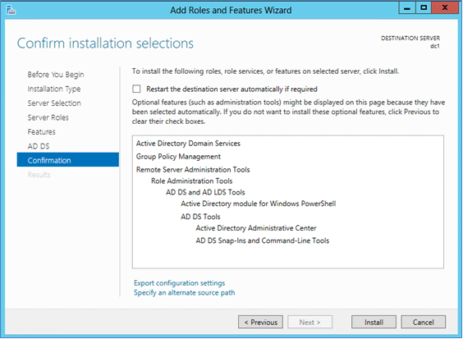

The **Confirmation** dialog is the final checkpoint before role installation starts. It offers an option to restart the computer as needed after role installation, but AD DS installation does not require a reboot.

By clicking **Install**, you confirm you are ready to begin role installation. You cannot cancel a role installation once it begins.

##### Results

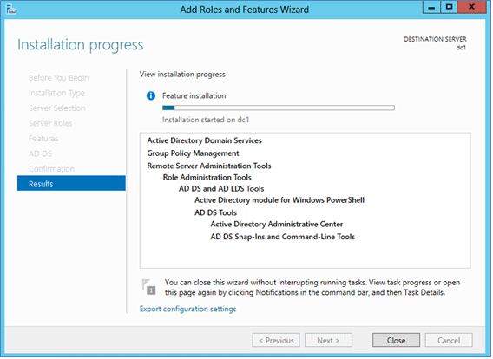

The **Results** dialog shows the current installation progress and current installation status. Role installation continues regardless of whether Server Manager is closed.

Verifying the installation results is still a best practice. If you close the **Results** dialog before installation completes, you can check the results using the Server Manager notification flag. Server Manager also shows a warning message for any servers that have installed the AD DS role but not been further configured as domain controllers.

**Task Notifications**

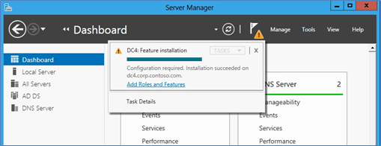

**AD DS Details**

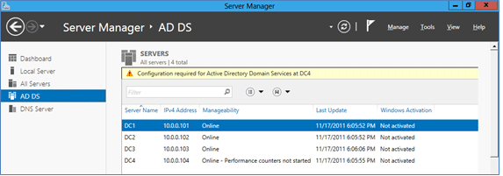

**Task Details**

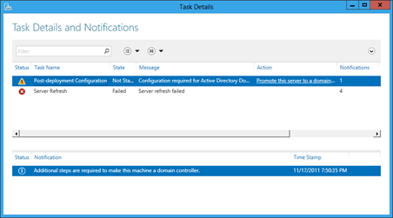

##### Promote to Domain Controller

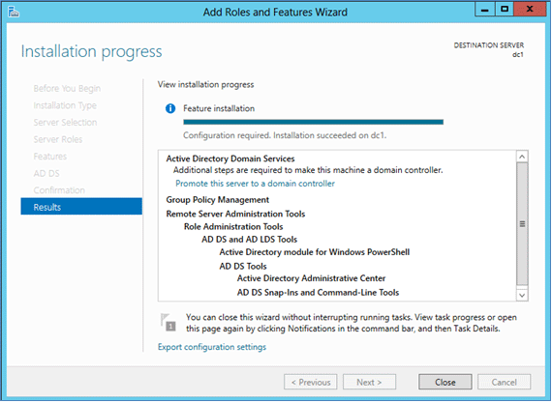

At the end of the AD DS role installation, you can continue with configuration by using the **Promote this server to a domain controller** link. This is required to make the server a domain controller, but is not necessary to run the configuration wizard immediately. For example, you may only want to provision servers with the AD DS binaries before sending them to another branch office for later configuration. By adding the AD DS role before shipping, you save time when it reaches its destination. You also follow the best practice of not keeping a domain controller offline for days or weeks. Finally, this enables you to update components before domain controller promotion, saving you at least one subsequent reboot.

Selecting this link later invokes the ADDSDeployment cmdlets: **install-addsforest**, **install-addsdomain**, or **install-addsdomaincontroller**.

##### Configure Domain Controller

In the **Active Directory Domain Services Installation Wizard** dialog, configure a new domain controller by stepping through the pages with the settings below.

|  |  |
| --- | --- |
| **Page / Option** | **Settings** |
| Deployment Configuration | Add a new forest |
| Root Domain Name | Your company domain name (e.g. corp.contoso.com) |
| Choose a Deployment Configuration | **Create a new domain in a new forest** = **Selected** |
| Set Forest Functional Level | **Forest functional level** = **Windows Server 2012 R2** |
| Set Domain Functional Level | **Forest functional level** = **Windows Server 2012 R2** |
| Domain Name System(DNS) | **Selected** |
| Directory Services Restore Mode Administrator Password | **Password** = **Contoso!000**  **Confirm Password** = **Contoso!000** |
| Domain NetBIOS Name | Use defaults |
| Place Database, log files and SYSVOL in the drive created on Task 1 |  |

**After the DC server is provisioned, the VM restarts automatically.**

##### Configure Domain Controller User Account

1. Next, you configure Active Directory (AD) with the accounts you will use later. Launch the RDP file for ContosoDC again using the default domain administrator
2. Once you log in, open **Active Directory Users and Computers** from the **Start** menu, as shown below.

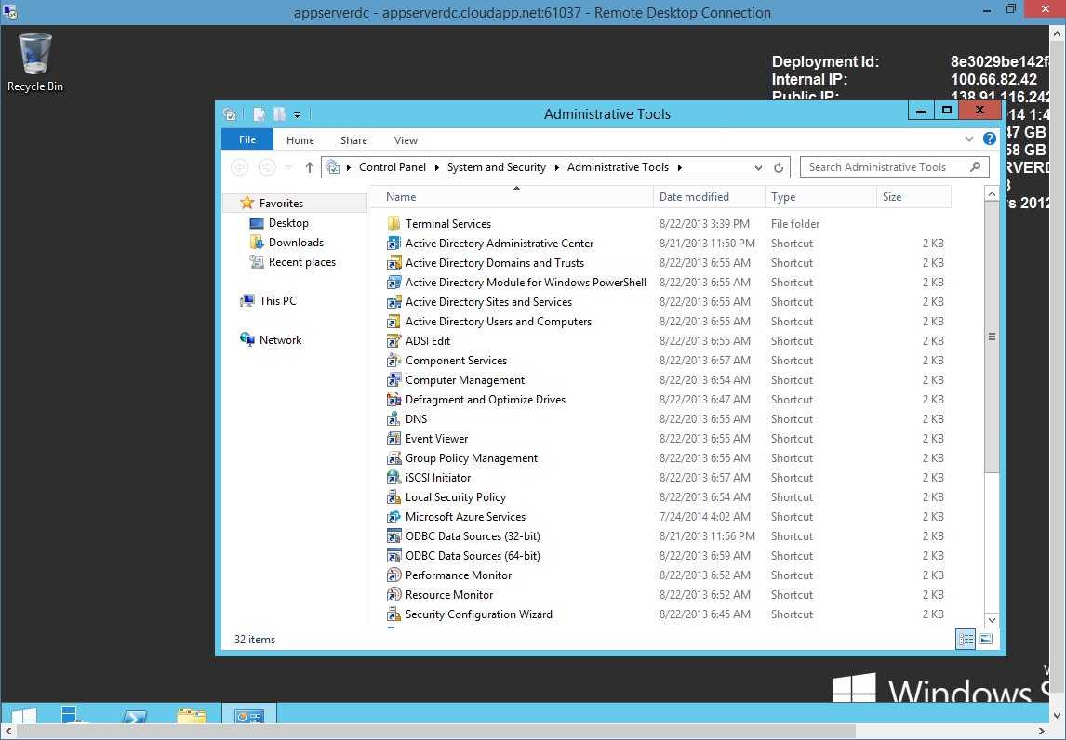

1. Expand **corp.contoso.com**, then right-click **Users**, then point to **New**, then click **User**.
2. Specify a user named **Install** as shown below and click **Next**.
3. Specify and confirm the account password (for example, **Contoso!000**), then select the check boxes as shown below, and then click **Next**.
   * **User must change password at next logon** = **Cleared**
   * **Password never expires** = **Selected**
4. Click **Finish**. You have now created **CORP\Install** in AD. You will use this account to configure the failover cluster and the availability group.
5. Following the same steps, create two additional accounts: **CORP\SQLSvc1** and **CORP\SQLSvc2**. You will use them as service accounts for the SQL Server instances.

Next, you need to give **CORP\Install** the necessary permissions for configuring Windows Service Failover Clustering (WSFC).

1. In the **View** menu, click **Advanced Features**, as shown below. This action lets you see all the hidden containers, as well as hidden tabs in the properties windows for AD objects.

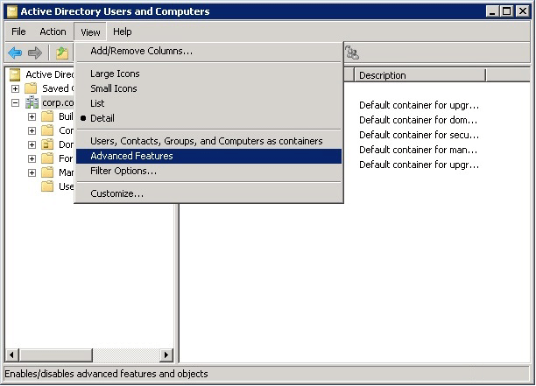

1. Right-click **corp.contoso.com** and click **Properties**.
2. In **corp.contos.com Properties**, select the **Security** tab, then click the **Advanced** button.
3. In **Advanced Security Settings for corp**, click **Add**.
4. Type **CORP\Install** in the text box and click **OK**.
5. Select **Allow for Read all properties** and **Create Computer objects** as shown below, then click **OK** three times to exit **corp.contoso.com Properties**.

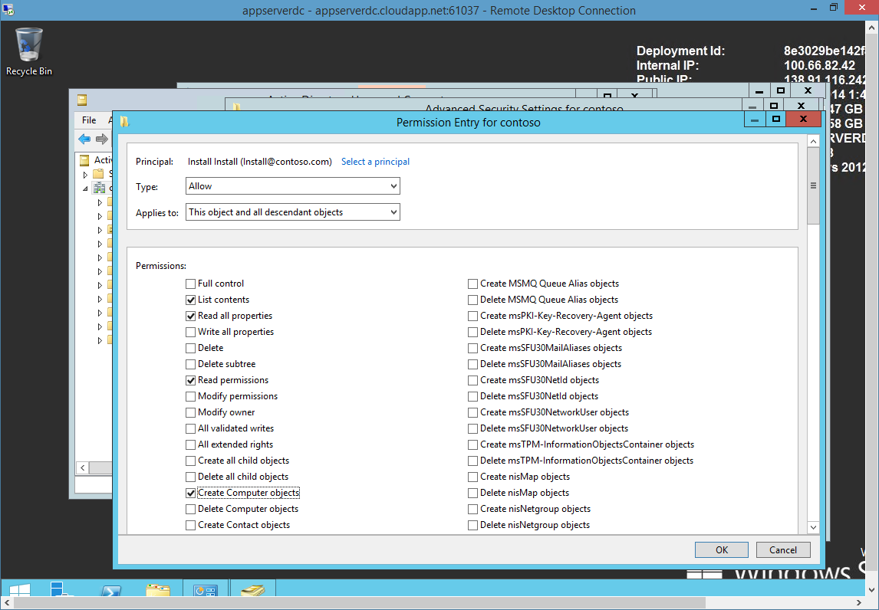

You have finished configuring Active Directory and the user objects; you will later create three SQL Server VMs and join them to this domain.

1. Repeat Task 1 and Task 2 to create a replica Domain Controller VM for achieving High Availability. Make sure to add the new VM to the same availability Set. <http://azure.microsoft.com/en-us/documentation/articles/virtual-networks-install-replica-active-directory-domain-controller/>

#### Step 3: Set the DNS server for the Azure virtual network

### Exercise 5: Creating SQL Server Virtual Machines

* 1. The link below contains a similar lab to SQL Server Always on via PowerShell, which is similar to the content **covered on this Exercise**. However, it does provide selecting an existing VPN, neither an existing DC. Customization is needed to support the PowerShell with this lab configuration. [SQL Server Always On - PowerShell](http://blogs.msdn.com/b/sqlalwayson/archive/2012/02/03/configuring-alwayson-with-sql-server-powershell.aspx)

Azure virtual machines (VMs) can help database administrators to implement lower the cost of a high availability SQL Server system. This tutorial shows you how to implement an availability group using SQL Server AlwaysOn end-to-end inside an Azure environment. At the end of the tutorial, your SQL Server AlwaysOn solution in Azure will consist of the following elements:

* Three VMs are deployed in the same affinity group, virtual network, subnet, and cloud service and use the same storage account
* The three VMs form a three-node Windows Server Failover Clustering (WSFC) cluster and are deployed in the same subnet and availability set
* Two of the WSFC nodes contain SQL Server instances and host an availability group with an availability database

The figure below is a graphical representation of the solution.

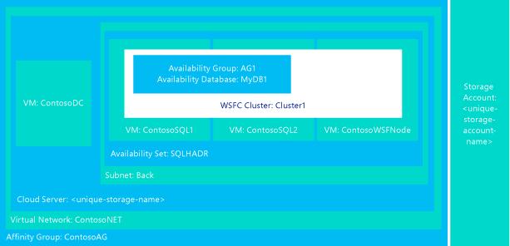

This scenario is chosen for its simplicity, not for its cost effectiveness or other factors on Azure. For example, you can minimize the number of VMs for a two-replica availability group in order to save on compute hours in Azure by using the domain controller as the quorum file share witness in a 2-node WSFC cluster. This method reduces the VM count by one from the above configuration.

Extracted and adapted from [AlwaysOn Availability Groups in Azure (GUI)](http://msdn.microsoft.com/library/azure/dn249504.aspx)

#### Task 1 - Create the SQL Server VMs

1. Next, you create the three VMs you will use which includes a WSFC cluster node and two SQL Server VMs. To create each of the VMs, go back to the Azure portal, then click **New**, then **Compute**, then **Virtual Machine**, and then **From Gallery**. Then, use the templates in the following table to help you create the VMs.
2. A

|  |  |  |  |
| --- | --- | --- | --- |
| **Page** | **VM1** | **VM2** | **VM3** |
| Select the virtual machine operating system | **Windows Server 2012 Datacenter  * Make sure not to select R2** | **SQL Server 2012 SP1 Enterprise Windows Server 2012** | **SQL Server 2012 SP1 Enterprise Windows Server 2012** |
| Virtual machine configuration | **VERSION RELEASE DATE** = (latest)  **VIRTUAL MACHINE NAME** = **ContosoWSFCNode**  SIZE = **Medium**  **NEW USER NAME** = **AzureAdmin**  **NEW PASSWORD** = **Contoso!000**  **CONFIRM** = **Contoso!000** | **VIRTUAL MACHINE NAME** = **ContosoSQL1**  **SIZE** = **Large**  **NEW USER NAME** = **AzureAdmin**  **NEW PASSWORD** = **Contoso!000** | **VIRTUAL MACHINE NAME** = **ContosoSQL2**  **SIZE** = **Large**  **NEW USER NAME** = **AzureAdmin**  **NEW PASSWORD** = **Contoso!000**  **CONFIRM** = **Contoso!000** |
| Virtual machine mode | **CLOUD SERVICE** = **Selected (CSAppServerContoso)**  **STORAGE ACCOUNT** = the storage account you created  **REGION/AFFINITY GROUP/VIRTUAL NETWORK** = **Select VNET created previously**  **VIRTUAL NETWORK SUBNETS** = **SubnetData (10.32.0.0)** | **CLOUD SERVICE** = **Selected (CSAppServerContoso STORAGE**  **ACCOUNT** = the storage account you created  **REGION/AFFINITY GROUP/VIRTUAL NETWORK** = **Select VNET created previously**  **VIRTUAL NETWORK SUBNETS** = **SubnetData (10.32.0.0)** | **CLOUD SERVICE** = **Selected (CSAppServerContoso STORAGE**  **ACCOUNT** = the storage account you created  **REGION/AFFINITY GROUP/VIRTUAL NETWORK** = **Select VNET created previously**  **VIRTUAL NETWORK SUBNETS** = **SubnetData (10.32.0.0)** |
| Virtual machine options | **AVAILABILITY SET** = **Create an availability set**  **AVAILABILITY SET NAME** = **SQLHADR** | **AVAILABILITY SET** = **SQLHADR** | **AVAILABILITY SET** = **SQLHADR** |

Once the three VMs are fully provisioned, you need to join them to the corp.contoso.com domain and grant CORP\Install administrative rights to the machines. To do this, follow the steps below for each of the three VMs.

1. Download each VM's remote desktop (RDP) file to your local directory by selecting the VM in the list and clicking the **Connect** button. To select a VM, click anywhere but the first cell in the row, as shown below.

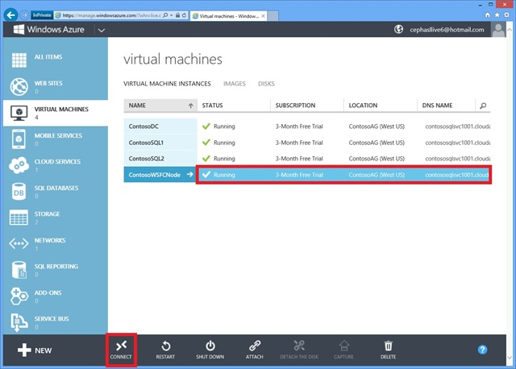

1. Launch the RDP file you downloaded and log into the VM using your configured administrator account (**BUILTIN\AzureAdmin**).
2. Back in the **Initial Configuration Tasks**, click the **Provide computer name and domain** link.
3. In the **System Properties** dialog, click **Change**.
4. Select the **Domain** check box and type **corp.contoso.com** in the text box, then click **OK**.
5. In the **Windows Security** popup dialog, specify the credentials for the default domain administrator account (**CORP\AzureAdmin**) and the password **Contoso!000**.
6. When you see the "Welcome to the corp.contoso.com domain" message, click **OK**.
7. In **Computer Name/Domain Changes**, click **OK**, then click **OK** in the popup dialog.
8. Wait until the VM is restarted, then launch the RDP file again to log into the VM using the **BUILTIN\AzureAdmin** account.
9. In the Charm Bar >> Search Charm, type "user", then click **Give administrative rights to a domain user**, as shown below.

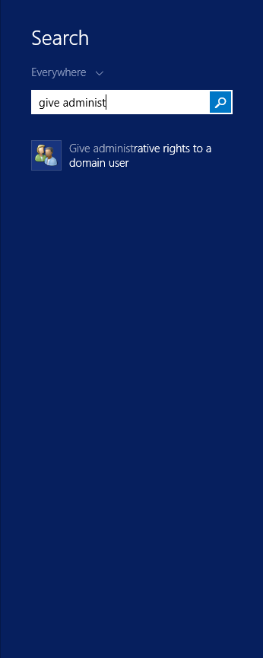

1. In the **User Accounts** dialog, click **Add**.
2. In Add New User, specify **Install** in **User name** and **CORP** in **Domain**, then click **Next**.
3. Select **Administrator** to add the CORP\Install to the local Administrators group, then click **Finish**, and then click **OK** to close the **User Accounts** dialog.
4. Next, you add the **Failover Clustering** feature to the VM. In the **Initial Configuration Tasks** window, click **Add features**.
5. In the **Add Features Wizard**, select **Failover Clustering** as shown below and click **Next**.

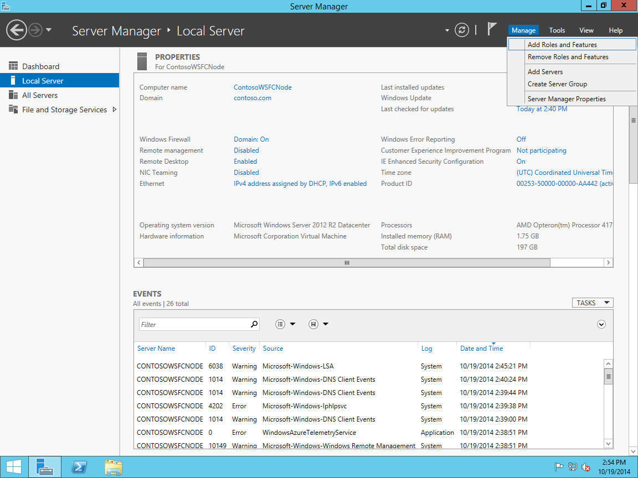

Keep default option until **Features**

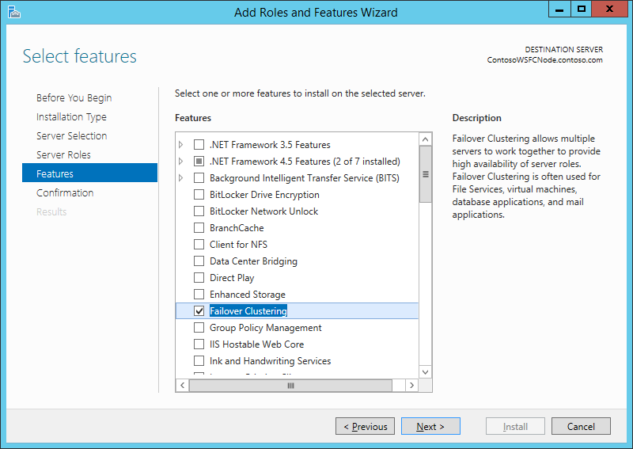

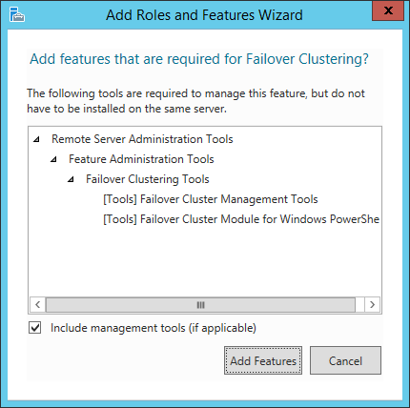

1. In **Confirm Installation Selections**, click **Install**.
2. When the **Failover Clustering** feature installation is completed, click **Close**.
3. Don’t close the RDS session, you will use in the next task.

The SQL Server VMs are now provisioned and running, but they are installed with SQL Server with default options.

#### Task 2 - Attaching Empty Disk Images

In this task, you will create two empty data disks and attach them to an existing Virtual Machine using the Microsoft Azure Management Portal. You will use these data disks to split SQL Server Data and Logs.

1. Now, you will create and attach empty data disks to store the SQL Server logs and data files, and you will also add an endpoint. To do this, in the **Virtual Machines** section, select the SQL Server Virtual Machine you created in the previous task.
2. In the Virtual Machine's **Dashboard**, click **Attach** in the menu at the bottom of the page and select **Attach Empty Disk**.

[](https://github.com/WindowsAzure-TrainingKit/HOL-IntroToWindowsAzureVirtualMachines/blob/master/Images/attach-empty-disk.png?raw=true)

Attach Empty Disk

1. In the **Attach Empty Disk** page, set the **Size** to 50 GB and create the Disk.
2. Wait until the process to attach the disk finishes. Repeat the steps 1 to 3 to create a second disk.
3. Open the Virtual Machine's **Dashboard**. You will see three disks: one for the **OS** and other two for **Data** and **Logs**.

**Note:** It might take a few minutes until the data disks appear in the Virtual Machine's dashboard within the Azure Portal.

[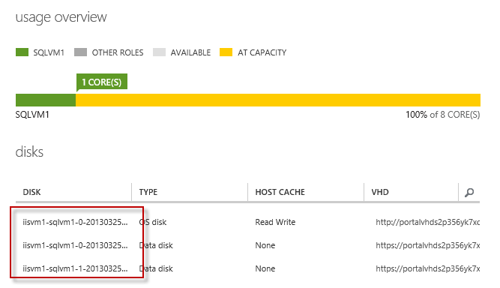](https://github.com/WindowsAzure-TrainingKit/HOL-IntroToWindowsAzureVirtualMachines/blob/master/Images/Attached-Data-Disks.png?raw=true)

Attached Data Disks

1. Finally, you need to format the disks in order to access them from the Virtual Machine. To do this, click **Connect** to connect to the Virtual Machine using **Remote Desktop connection**.
2. It will ask you to download the remote desktop settings file. Click **Open** and log on using the credentials you defined when creating the Virtual Machine.
3. In the virtual machine, open **Server Manager** from **Tools | Computer Management**

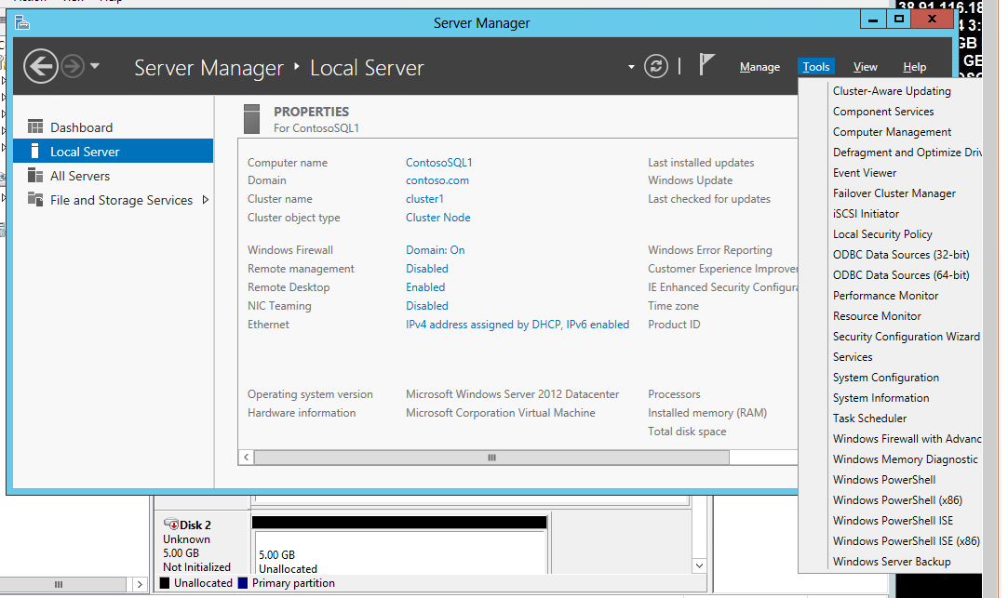

1. Expand **Storage** node and select **Disk Management** option.

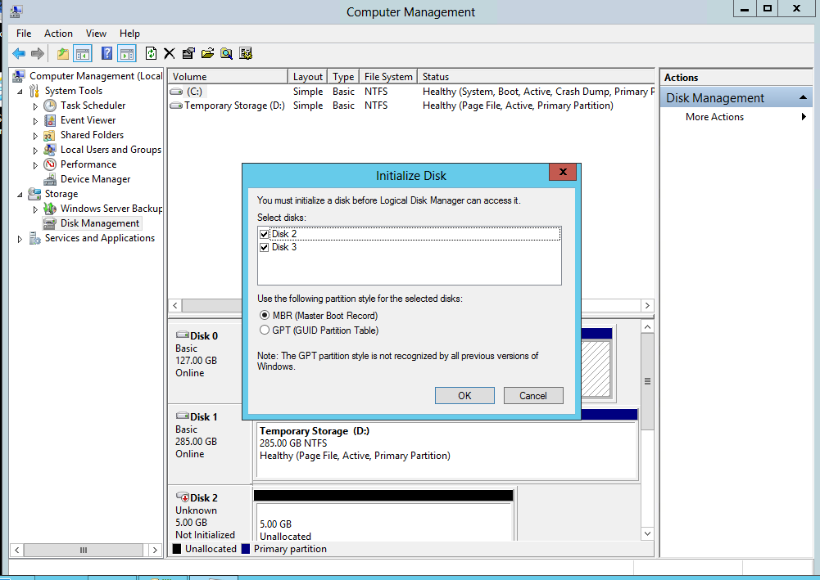

Disks Management

1. The **Initialize Disk** dialog will appear. Leave the default values and click **OK**.
2. Right-click the first disk unallocated space and select **New Simple Volume**.

[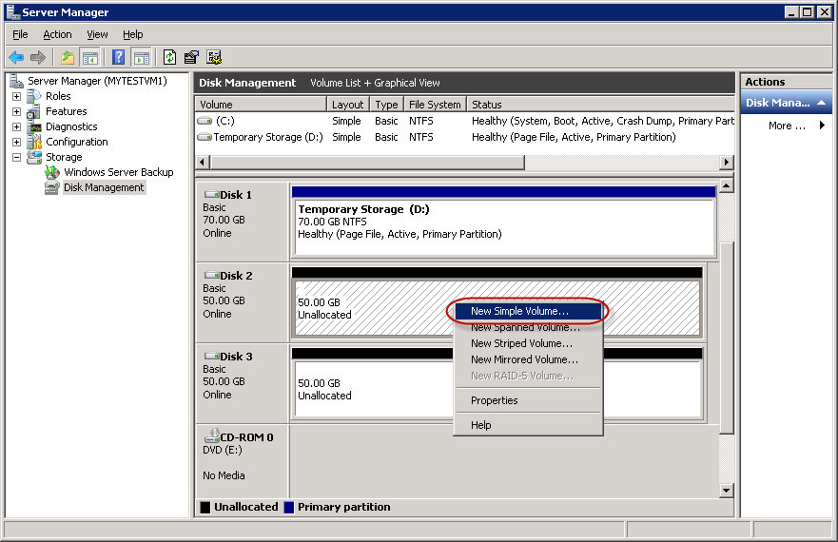](https://github.com/WindowsAzure-TrainingKit/HOL-IntroToWindowsAzureVirtualMachines/blob/master/Images/disk-management.png?raw=true)

Disks Management

1. Follow the **New Simple Volume Wizard**. When asked for the **Volume Label** use SQLData.
2. Wait until the process for the first disk is completed. Repeat the steps 11 to 12 but this time using the second disk. Set the **Volume Label** to SQLLogs.
3. The **Disk Management** list of available disks should now show the **SQLData** and **SQLLogs** disks like in the following figure:

[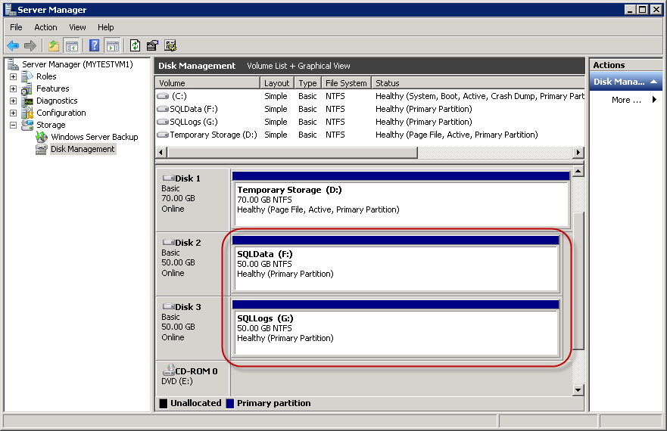](https://github.com/WindowsAzure-TrainingKit/HOL-IntroToWindowsAzureVirtualMachines/blob/master/Images/Disks-Management.png?raw=true)

Disks Management

1. Repeat the steps above for the **SQL Server 2 Virtual Machine**:

#### Task 3 - Create the WSFC Cluster

In this section, you create the WSFC cluster that will host the availability group you will create later. By now, you should have done the following to each of the three VMs you will use in the WSFC cluster:

* Fully provisioned in Azure
* Joined VM to the domain
* Added CORP\Install to the local Administrators group
* Added the Failover Clustering feature

All these are prerequisites on each VM before you can join it to the WSFC cluster.

Also, note that the Azure virtual network does not behave in the same way as an on-premise network, you need to create the cluster in the following order:

1. Create a single-node cluster on one of the nodes (ContosoSQL1)
2. Modify the cluster IP address to an unused IP address (10.10.2.101)
3. Bring the cluster name online
4. Add the other nodes (ContosoSQL2 and ContosoWSFCNode)

Finally, you are ready to move on. Follow the steps below to fully configure the cluster.

1. Launch the RDP file for ContosoSQL1 and log in using the credentials for CORP\Install.
2. Open the **Start Screen**, Search, **Failover Cluster** node,

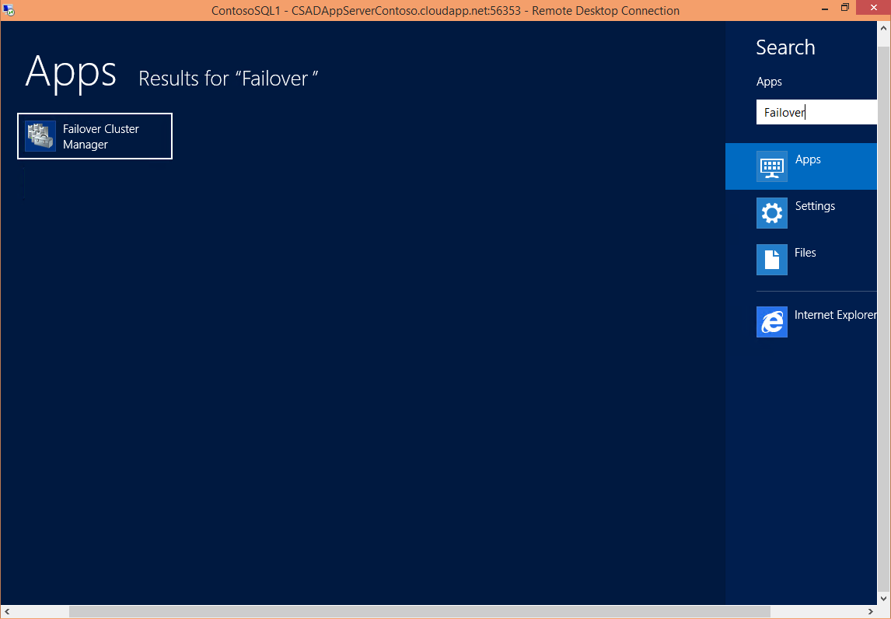

1. Right-click **Failover Cluster Manager**, and then click **Create a Cluster**, as shown below.

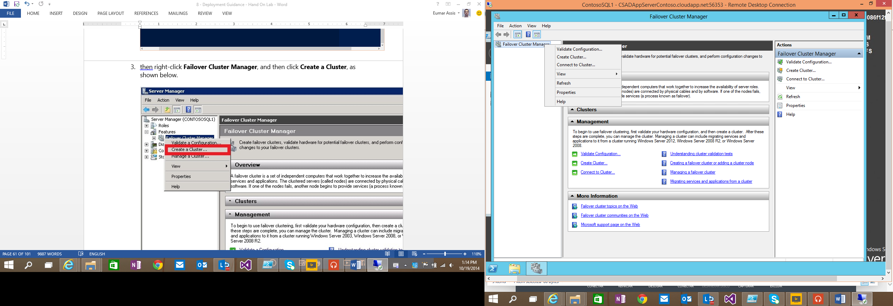

1. In the Create Cluster Wizard, create a one-node cluster by stepping through the pages with the settings below:

|  |  |
| --- | --- |
| **Page** | **Settings** |
| Before You Begin | Use defaults |
| Select Servers | Type **ContosoSQL1** in **Enter server name** and click **Add** |
| Validation Warning | Select **No. I do not require support from Microsoft for this cluster, and therefore do not want to run the validation tests. When I click Next, continue creating the cluster.** |
| Access Point for Administering the Cluster | Type **Cluster1** in **Cluster Name** |
| Confirmation | Use defaults |

1. In **Failover Cluster Manager**, then click **Cluster1.corp.contoso.com**, then scroll down in the center pane, and then expand **Cluster Core Resources**. You should see both the **Name** and the **IP Address** resources in the **Failed** state. The IP address resource cannot be brought online because the cluster is assigned the same IP address as that of the machine itself, which is a duplicate address. Right-click the failed **IP Address** resource, and then click **Properties**, as shown below.

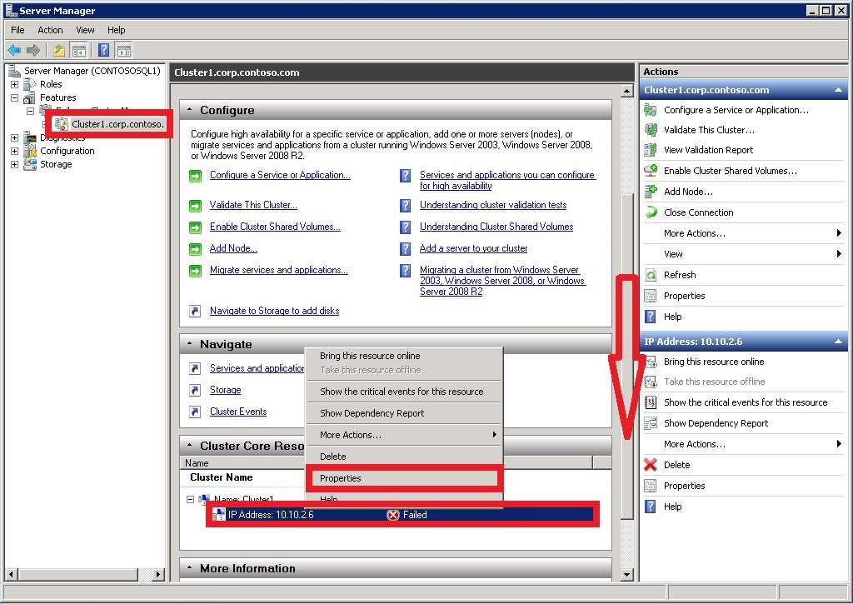

1. Select **Static IP Address** and specify **10.32.0.9** in the Address text box, as shown below. Then, click **OK**.
2. In the **Cluster Core Resources** section, right-click **Name: Cluster1** and click **Bring online**. Then, wait until both resources are online. When the cluster name resource comes online, it updates the DC server with a new AD computer account. This AD account will be used to run the availability group clustered service later.
3. Finally, you add the remaining nodes to the cluster. In the browser tree, right-click **Cluster1.corp.contoso.com** and click **Add Node**, as shown below.

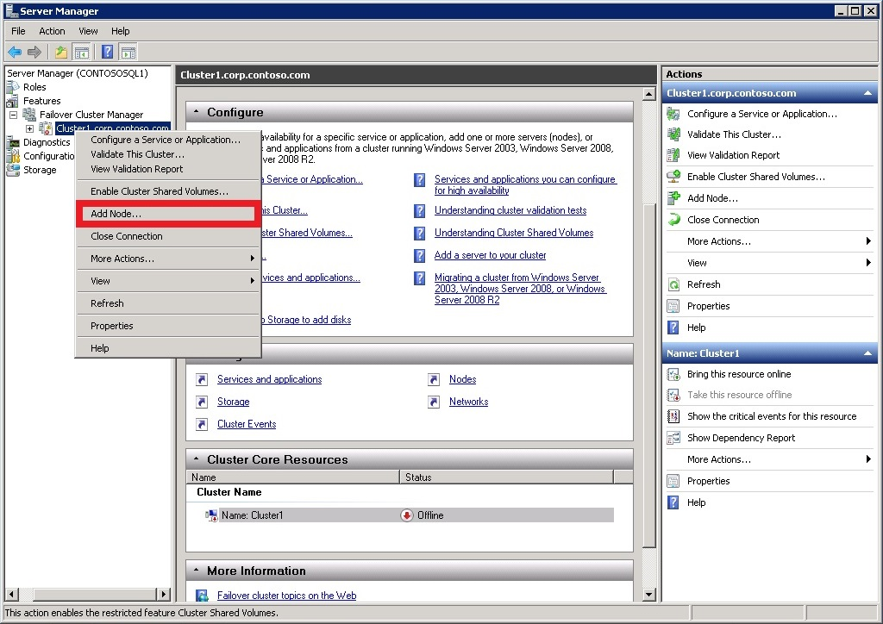

1. In the **Add Node Wizard**, click **Next**. Then, in the **Select Servers** page, add **ContosoSQL2** and **ContosoWSFCNode** to the list by typing the server name in **Enter server name** and then clicking **Add**. When you are done, click **Next**.
   1. Note: Make sure all members of the Cluster are using the same OS versions
2. In the **Validation Warning** page, click **No, I do not require support from Microsoft for this cluster, and therefore do not want to run the validation tests. When I click Next, continue creating the cluster.** Then, click **Next** twice to add the nodes. Once the nodes are added to the cluster, click **Finish**.

**Failover Cluster Manager** should now show that your cluster has three nodes and list them in the **Nodes** container, as shown below.

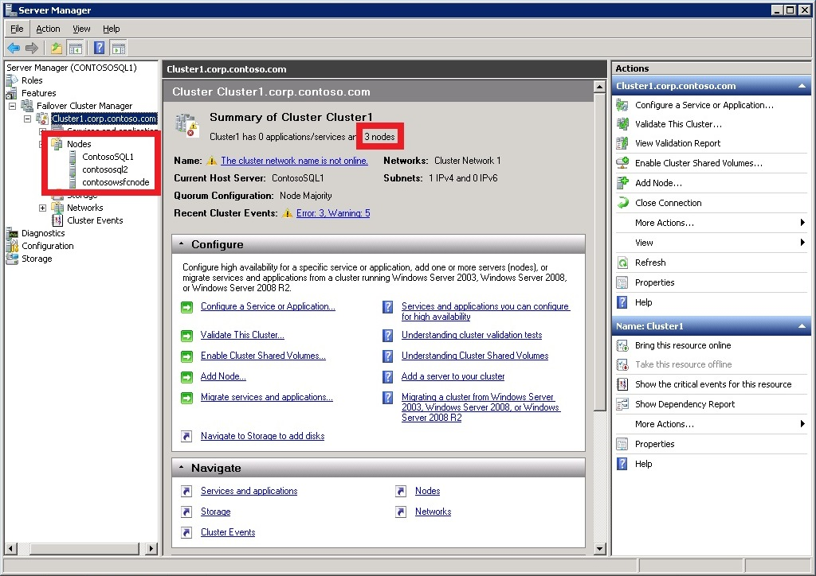

1. Log out of the remote desktop session.

#### Task 4 - Prepare the SQL Server Instances for Availability Group

In this section, you will do the following on both ContosoSQL1 and contosoSQL2:

1. Add a login for NT AUTHORITY\System with a necessary permissions set to the default SQL Server instance
2. Add CORP\Install as a sysadmin role to the default SQL Server instance
3. Open the firewall for remote access of SQL Server
4. Enable the AlwaysOn Availability Groups feature
5. Change the SQL Server service account to CORP\SQLSvc1 and CORP\SQLSvc2, respectively

The actions above can be performed in any order. Nevertheless, the steps below will walk through them in order. Follow the steps for both ContosoSQL1 and ContosoSQL2:

1. If you have not logged out of the remote desktop session for the VM, do so now.
2. Launch the RDP file for the VM and log in as BUILTIN\AzureAdmin.
3. First, you add NT AUTHORITY\System to the SQL Server logins and with necessary permissions. From the **Start** menu, launch **SQL Server Management Studio**.
4. Click **Connect** to connect to the default SQL Server instance.
5. In **Object Explorer**, expand **Security**, right-click **Logins**, and click **New Login**.
6. Type **NT AUTHORITY\System** in **Login name** and click **OK**.
7. In **Object Explorer**, right-click **NT AUTHORITY\System** and click **Properties**.
8. In the **Securables** page, for the local server, select **Grant** for the following permissions and click **OK**.
   * **Alter any availability group**
   * **Connect SQL**
   * **View server state**
9. Next, you add CORP\Install as a sysadmin role to the default SQL Server instance. In **Object Explorer**, right-click **Logins** again and click **New Login**.
10. Type **CORP\Install** in **Login name**.
11. In the **Server Roles** page, select **sysadmin**. Then, click **OK**. Once the login is created, you can see it by expanding **Logins** in **Object Explorer**.
12. Next, you create a firewall rule for SQL Server. From the **Start** menu, launch **Windows Firewall with Advanced Security**, as shown below.

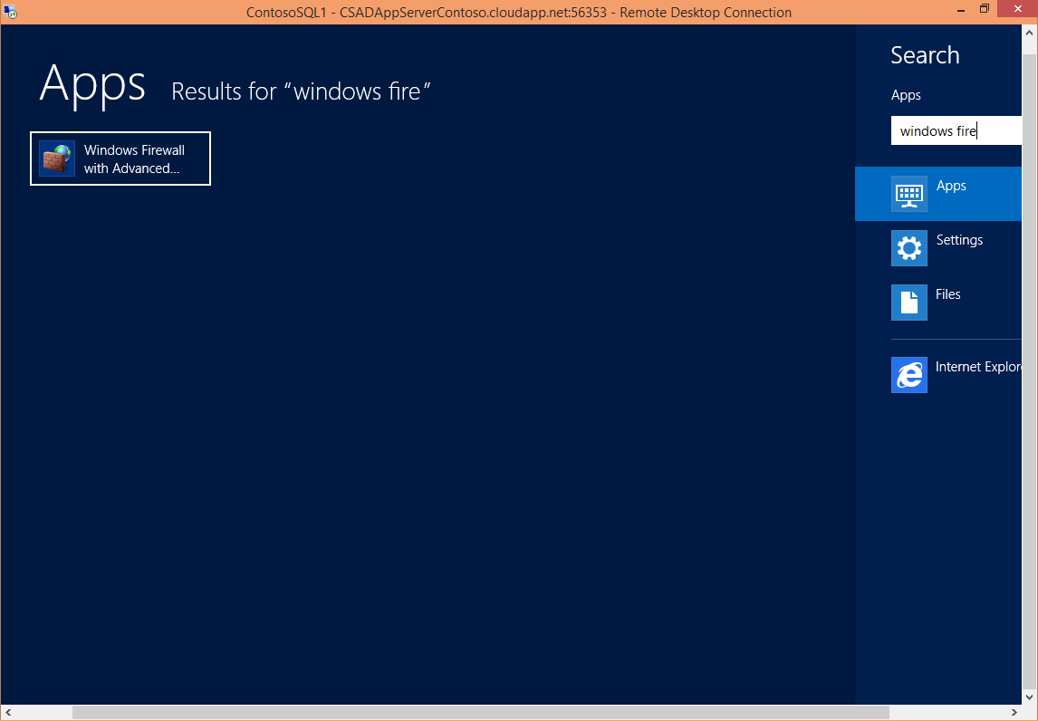

1. Right-click **Inbound Rules** and click **New Rule**.
2. In the **Rule Type** page, select **Program**, then click **Next**.
3. In the **Program** page, select **This program path** and type **%ProgramFiles%\Microsoft SQL Server\MSSQL11.MSSQLSERVER\MSSQL\Binn\sqlservr.exe** in the text box. Then, click **Next**.
4. In the **Action** page, keep **Allow the connection** selected and click **Next**.
5. In the **Profile** page, accept the default settings and click **Next**.
6. In the **Name** page, specify a rule name, such as **SQL Server (Program Rule)** in the **Name** text box, then click **Finish**.
7. Next, you enable the AlwaysOn Availability Groups feature. From the Start menu, launch SQL Server Configuration Manager.
8. In the browser tree, click **SQL Server Services**, then right-click the **SQL Server (MSSQLSERVER)** service and click **Properties**.
9. Click the **AlwaysOn High Availability** tab, then select **Enable AlwaysOn Availability Groups**, as shown below, and then click **Apply**. Click **OK** in the pop-up dialog, and do not close the properties window yet. You will restart the SQL Server service after you change the service account.

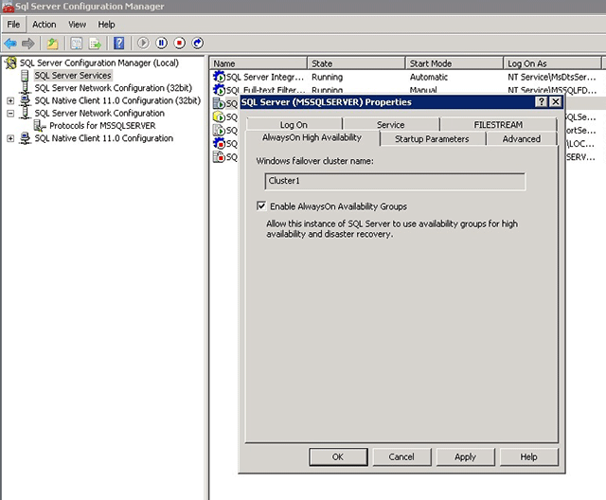

1. Next, you change the SQL Server service account. Click the **Log On** tab, then type **CORP\SQLSvc1** (for ContosoSQL1) or **CORP\SQLSvc2** (for ContosoSQL2) in **Account Name**, then fill in and confirm the password, and then click **OK**.
2. In the pop-up window, click **Yes** to restart the SQL Server service. After the SQL Server service is restarted, the changes you made in the properties window are effective.

#### Task 5 - Configure AdventureWorksDatabase

In this task, you will configure SQL Server 2012. You will create the database that will be used by the MVC4 application and add Full-Text Search capabilities to it. Additionally, you will create a SQL Server user for the MVC4 website.

1. If you have not logged out of the remote desktop session for the VM, do so now.
2. Launch the RDP file for the VM and log in as BUILTIN\AzureAdmin.
3. Open Windows Explorer and create the following folders: **F:\Data, G:\Logs** and **G:\Backups**.
4. Open the SQL Server Management Studio from **Start Screen | SQL Server Management Studio**.
5. Connect to the SQL Server 2012 default instance using your Windows Account.
6. Now, you will update the database's default locations in order to split the DATA from the LOGS. To do this, right click on your SQL Server instance and select **Properties**.
7. Select **Database Settings** from the left side pane.
8. Locate the **Database default locations** section and update the default values to point to the disks you attached in the previous task and then click "Ok".

[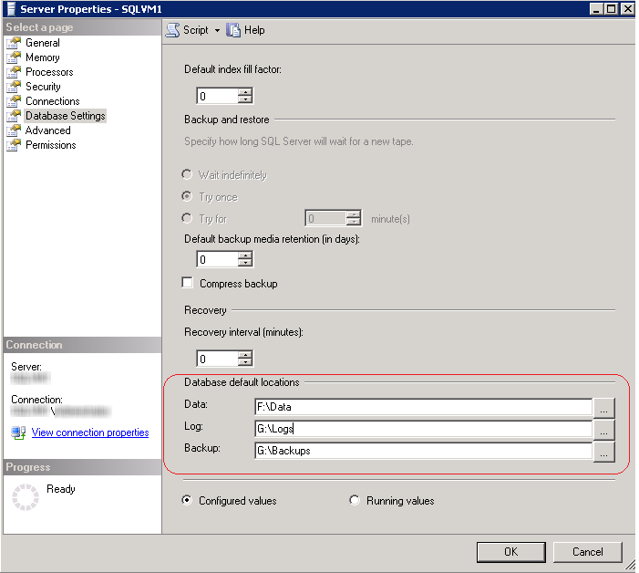](https://github.com/WindowsAzure-TrainingKit/HOL-IntroToWindowsAzureVirtualMachines/blob/master/Images/Setting-Database-Default-Locations.png?raw=true)

Setting Database Default Locations

1. Restart SQL Server. In the **Object Explorer**, right-click on the server node and select **Restart**.
2. In order to enable downloads from Internet Explorer you will need to update **Internet Explorer Enhanced Security Configuration**. In the Azure Virtual Machine, open **Server Manager** from **Start | Administrative Tools | Server Manager**.
3. In the **Server Manager**, click **Configure IE ESC** within **Security Information** section.

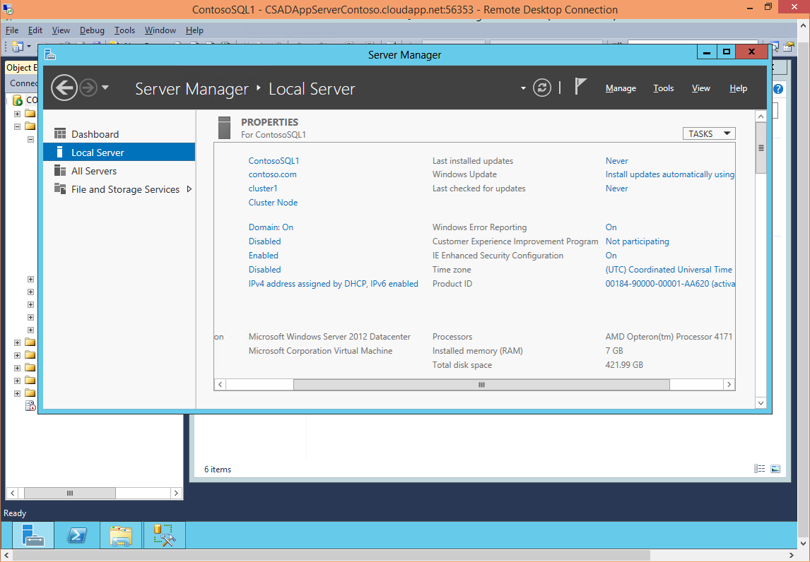

Configuring IE ESC

1. In the **Internet explorer Enhanced Security** configuration, turn **off** the enhanced security for **Administrators** and click **OK**.

[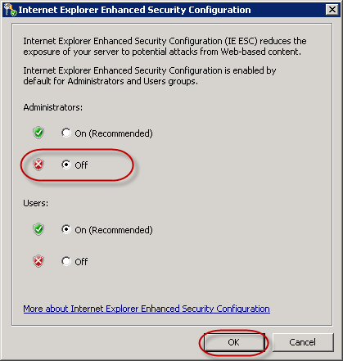](https://github.com/WindowsAzure-TrainingKit/HOL-IntroToWindowsAzureVirtualMachines/blob/master/Images/internet-explorer-enhanced-security2.png?raw=true)

Internet Explorer Enhanced Security

**Note:** Modifying **Internet Explorer Enhanced Security** configurations is not good practice and is only for the purpose of this particular lab. The correct approach should be to download the files locally and then copy them to a shared folder or directly to the Virtual Machine.

1. This lab uses the **AdventureWorks2012** database. Open an **Internet Explorer** browser and go to <http://msftdbprodsamples.codeplex.com/> to download the **SQL Server 2012** sample databases. Once on the page click on **AdventureWorks Databases – 2008, 2008R2 and 2012** and then download Adventure Works 2012 Data File. Download the file to F:\Data.

**Note:** The **AdventureWorks2012** database can also be downloaded as a .zip file. If you choose this format, right-click the file to open its properties window and then click **Unblock**. Then, extract the database to F:\Data.

1. Add the **AdventureWorks2012** sample database to your SQL Server. To do this, in the **SQL Server Management Studio**, locate your SQL Server instance node and expand it. Right click the **Databases** folder and select **Attach**.

[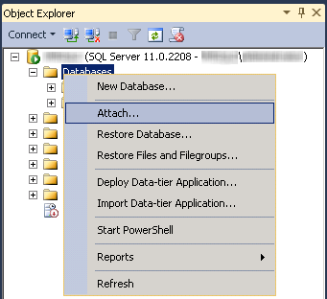](https://github.com/WindowsAzure-TrainingKit/HOL-IntroToWindowsAzureVirtualMachines/blob/master/Images/attaching-adventureworks-database-menu.png?raw=true)

Attaching the database

1. In the **Attach Databases** dialog, press **Add**. Browse to the data disk and select the Adventure Works 2012 data file.
2. Select the **AdventureWorks2012** Log entry and click **Remove**.

[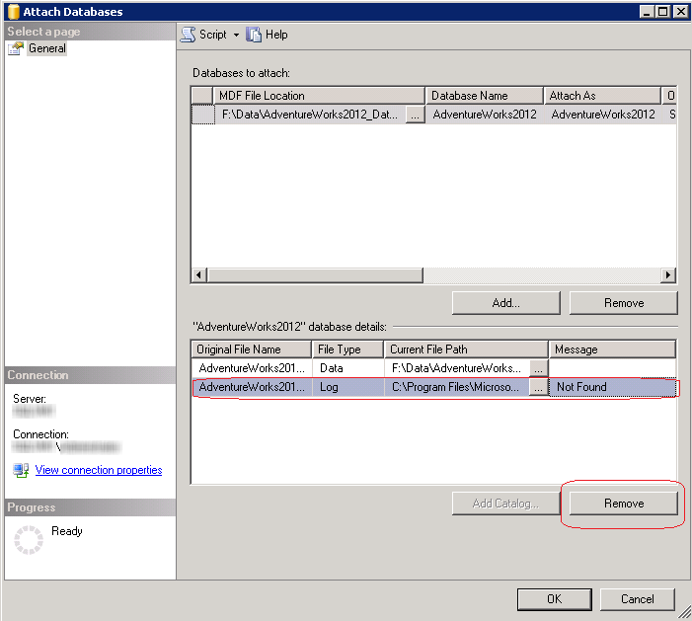](https://github.com/WindowsAzure-TrainingKit/HOL-IntroToWindowsAzureVirtualMachines/blob/master/Images/removing-adventureworks-log-entry.png?raw=true)

Removing AdventureWorks2012 Log entry

1. Press **OK** to add the database.
2. In the **Databases** folder, locate the new **AdventureWorks2012** database and explore its tables.

[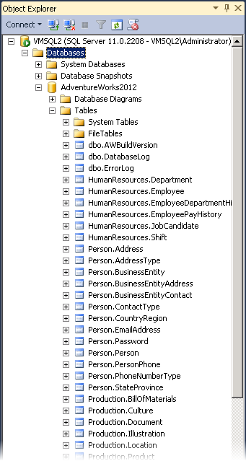](https://github.com/WindowsAzure-TrainingKit/HOL-IntroToWindowsAzureVirtualMachines/blob/master/Images/adventureworks-sample-database.png?raw=true)

AdventureWorks Sample Database

1. Expand **Storage** node within **AdventureWorks2012** database, right-click **Full Text Catalogs** folder and select **New Full-Text Catalog**.

**Note:** You are creating a Full Text Catalog for the database that will be used later by the MVC application.

[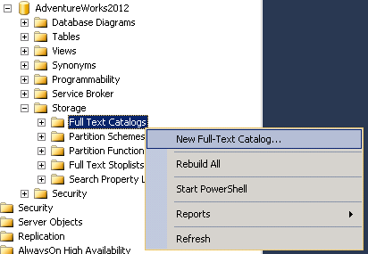](https://github.com/WindowsAzure-TrainingKit/HOL-IntroToWindowsAzureVirtualMachines/blob/master/Images/create-new-full-text-catalog2.png?raw=true)

Create New Full-Text Catalog

1. In the New Full-Text Catalog dialog, set the **Name** value to AdventureWorksCatalog and press **OK**.

[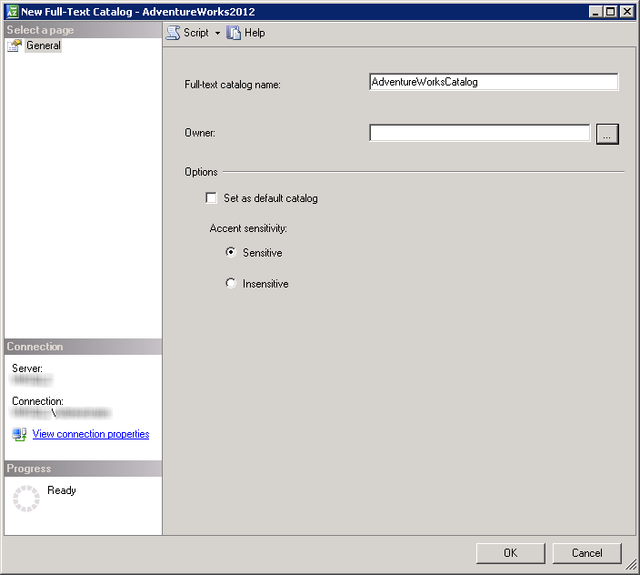](https://github.com/WindowsAzure-TrainingKit/HOL-IntroToWindowsAzureVirtualMachines/blob/master/Images/create-new-full-text-catalog3.png?raw=true)

Create New Full-Text Catalog

1. Check that the Full-Text Catalog you created appears in the **Full-Text Catalogs** folder.

[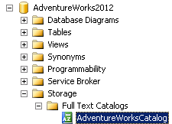](https://github.com/WindowsAzure-TrainingKit/HOL-IntroToWindowsAzureVirtualMachines/blob/master/Images/create-new-full-text-catalog5.png?raw=true)

Create New Full-Text Catalog

1. Right-click **AdventureWorksCatalog** and select **Properties**. In the **Full-Text Catalog Properties** dialog, switch to **Tables/Views** page.
2. Add the **Production.Product** table to the **Table/View objects assigned to the Catalog** list. Then, check the Name column and click **OK**.

[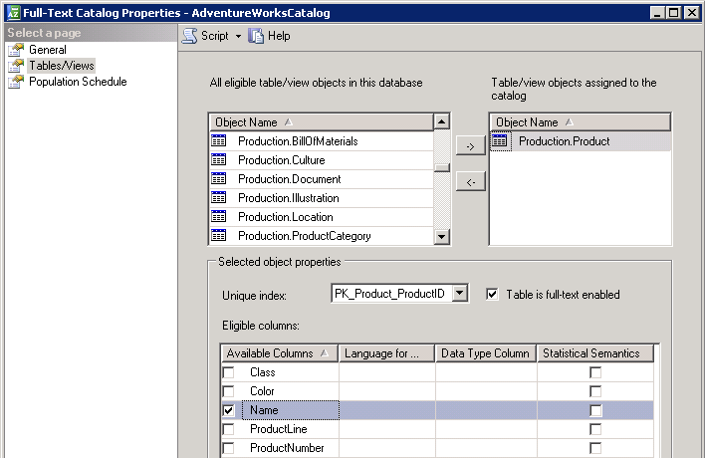](https://github.com/WindowsAzure-TrainingKit/HOL-IntroToWindowsAzureVirtualMachines/blob/master/Images/create-new-full-text-catalog4.png?raw=true)

Create New Full-Text Catalog

1. Add a new user for the MVC4 application you will deploy in the following exercise. To do this, expand **Security** folder within the SQL Server instance. Right-click **Logins** folder and select **New Login**.

[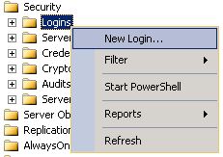](https://github.com/WindowsAzure-TrainingKit/HOL-IntroToWindowsAzureVirtualMachines/blob/master/Images/creating-a-new-login2.png?raw=true)

Creating a New Login

1. In the **General** section, set the **Login name** to CloudShop. Select **SQL Server authentication** option and set the **Password** to Azure$123.

**Note:** If you enter a different username or password than those suggested in this step, do not forget in the next exercise to update the web.config file of the MVC4 application to match those values.

1. Unselect **Enforce password policy** checkbox to avoid having to change the password the first time you log on, and set the **Default database** to AdventureWorks2012.

[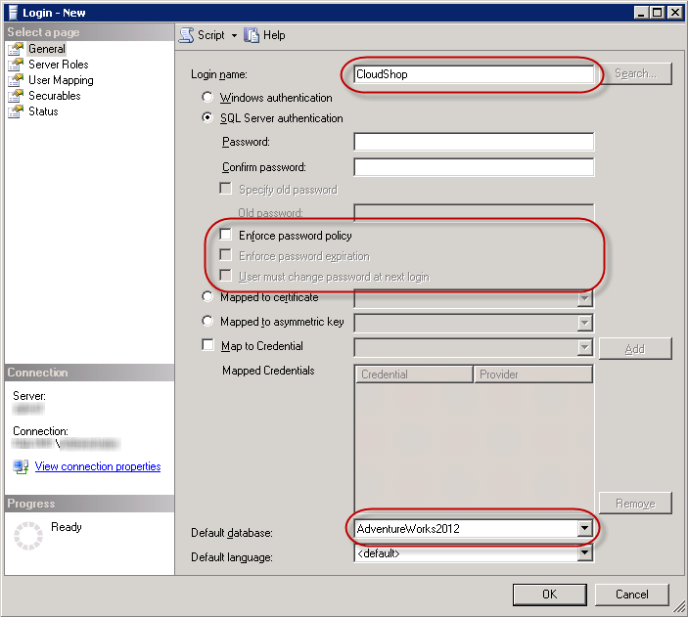](https://github.com/WindowsAzure-TrainingKit/HOL-IntroToWindowsAzureVirtualMachines/blob/master/Images/Creating-a-New-Login.png?raw=true)

Creating a New Login

1. Click **User Mapping** on the left pane. Select the map checkbox in the AdventureWorks2012 database row and click **OK**.

[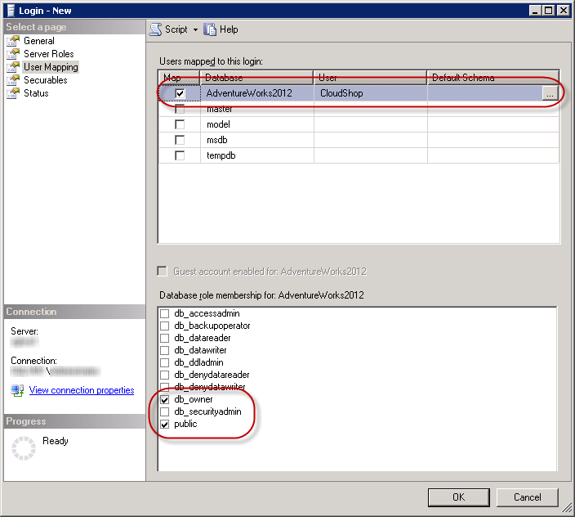](https://github.com/WindowsAzure-TrainingKit/HOL-IntroToWindowsAzureVirtualMachines/blob/master/Images/mapping-new-user-database-2.png?raw=true)

Mapping the new User to the AdventureWorks Database

1. Expand **AdventureWorks2012** database within **Databases** folder. In the **Users** folder under **Security**, double-click **CloudShop** user.
2. Select the **Membership** page, and select the db_owner role checkbox for the **CloudShop** user and click **OK**.

[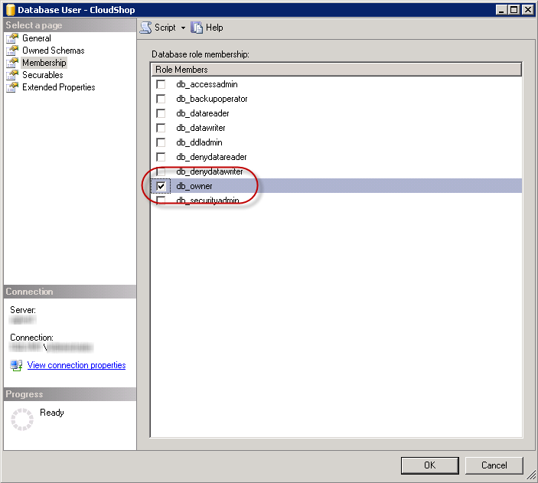](https://github.com/WindowsAzure-TrainingKit/HOL-IntroToWindowsAzureVirtualMachines/blob/master/Images/Adding-Database-role-membership-to-CloudShop-user.png?raw=true)

Adding Database role membership to CloudShop user

**Note:** The application you will deploy in the next exercise uses Universal Providers to manage sessions. The first time the application runs, the provider will create the Sessions table within the database. For that reason, you are assigning a db_owner role to the CloudShop user. Once you run the application for the first time, you can remove this role as these permissions will not be needed.

1. Now, enable **Mixed Mode Authentication** to the SQL Server instance. To do this, in the **SQL Server Management Studio**, right-click the server instance and click **Properties**.
2. Click **Security** in the left side pane and then select **SQL Server and Windows Authentication mode** under **Server Authentication** section. Click **OK** to save changes.
3. Restart the SQL Server instance. To do this, right-click the SQL Server instance and click **Restart**.
4. Close the **SQL Server Management Studio**.
5. Repeat the steps below on SQL Server Contoso 2 –
   1. Steps 1 through 12,
   2. Steps 24 through 28.
   3. You don´t need to create the AdventureWorks on SQL Server Contoso 2, you will create it via a Full Back up in the next Steps

#### Task 6 - Create the Availability Group

You are now ready to configure an availability group. Below is an outline of what you will do:

1. Take both a full backup and a transaction log backup of the database
2. Restore the full and log backups to ContosoSQL2 with the NORECOVERY option
3. Create the availability group (AG1) with synchronous commit, automatic failover, and readable secondary replicas

Follow the instructions below:

1. If you have not already logged out of the remote desktop sessions for ContosoSQL1 and ContosoSQL2, do so now.
2. Launch the RDP file for ContosoSQL1 and log in as **CORP\Install**.
3. In **File Explorer**, under **G:\Backups**, create a directory called **AdventureWorks**. You will use this directory use to back up and restore your database.
4. Right-click the new directory, point to **Share with**, and then click **Specific people**, as shown below.

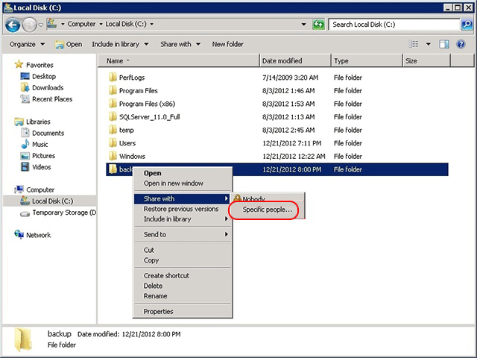

1. Add **CORP\SQLSvc1** and give it the **Read/Write** permission, then add **CORP\SQLSvc2** and give it the **Read** permission, as shown below, and then click **Share**. Once the file sharing process is complete, click **Done**.

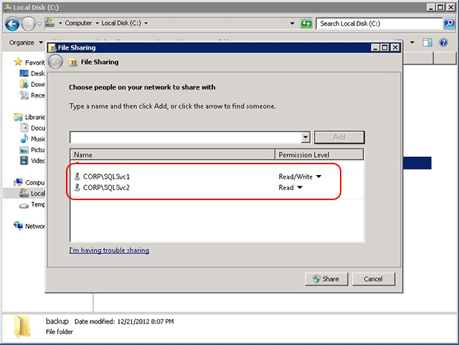

1. Next, you create the database. launch **SQL Server Management Studio**, then click **Connect** to connect to the default SQL Server instance.
2. In the **Object Explorer**, right-click **Databases** and click **AdventureWorks2012**.
3. Change the Recovery Mode to Full

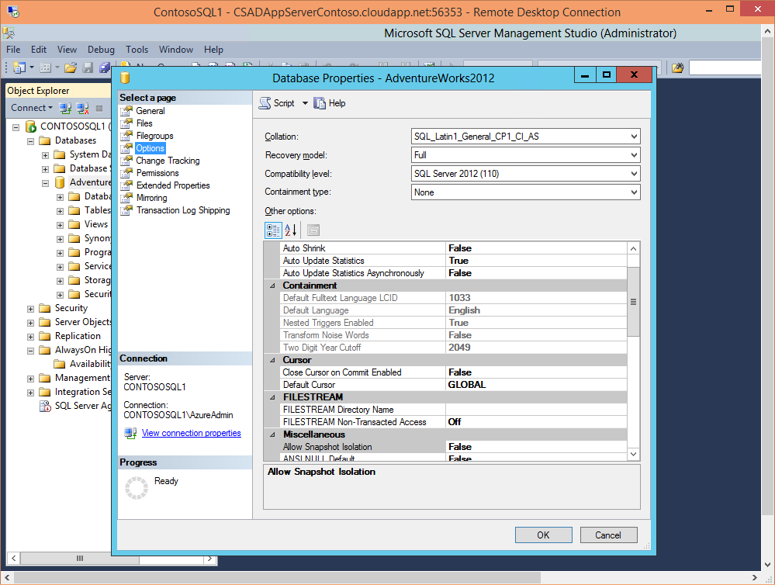

1. Next, you take a full backup of the database. In the **Object Explorer**, expand **Databases**, then right-click **AdventureWorks2012**, then point to **Tasks**, and then click **Back Up**.
2. In the **Source** section, keep **Backup type** set to **Full**. In the **Destination** section, click **Remove** to remove the default file path for the backup file.
3. In the **Destination** section, click **Add**.
4. In the **File name** text box, type **\\ContosoSQL1\backup\AdventureWorks.bak**. Then, click **OK**, and then click **OK** again to backup the database. When the backup operation completes, click **OK** again to close the dialog.
5. Next, you take a transaction log backup of the database. In the **Object Explorer**, expand **Databases**, then right-click **AdventureWorks2012**, then point to **Tasks**, and then click **Back Up**.
6. In **Backup** type, select **Transaction Log**. Keep the **Destination** file path set to the one you specified earlier and click **OK**. Once the backup operation completes, click **OK** again.
7. Next, you restore the full and transaction log backups on ContosoSQL2. Launch the RDP file for ContosoSQL2 and log in as **CORP\Install**. Leave the remote desktop session for ContosoSQL1 open.
8. From the **Start** menu, launch **SQL Server Management Studio**, then click **Connect** to connect to the default SQL Server instance.
9. In the **Object Explorer**, right-click **Databases** and click **Restore Database**.
10. In the **Source** section, select **Device**, and click the **…** button.
11. In **Select backup devices**, click **Add**.
12. In **Backup file location**, type **\\ContosoSQL1\backup**, then click **Refresh**, then select **AdventureWorks.bak**, then click **OK**, and then click **OK** again. You should now see the full backup and the log backup in the **Backup sets to restore** pane.
13. Go to the **Options** page, then select **RESTORE WITH NORECOVERY** in **Recovery state**, and then click **OK** to restore the database. Once the restore operation completes, click **OK**.
14. Now, you create an availability group. Go back to the remote desktop session for ContosoSQL1. In the **Object Explorer** in SSMS, right-click **AlwaysOn High Availability** and click **New Availability Group Wizard**, as shown below.

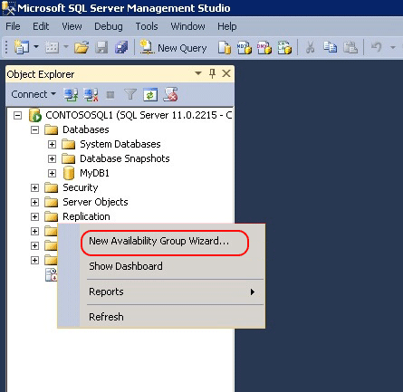

1. In the **Introduction** page, click **Next**. In the **Specify Availability Group Name** page, type **AG1** in **Availability group name**, then click **Next** again.

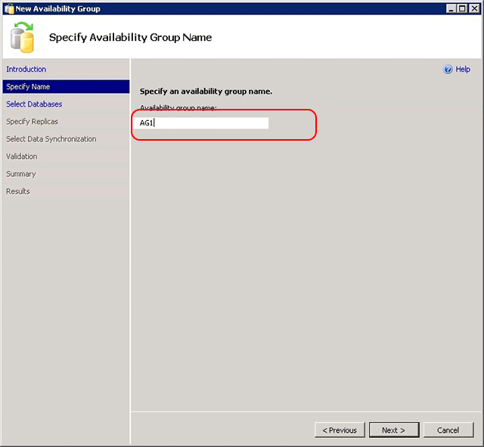

1. In the **Select Databases** page, select **AdventureWorks2012** and click **Next**. The database meets the prerequisites for an availability group because you have taken at least one full backup on the intended primary replica.

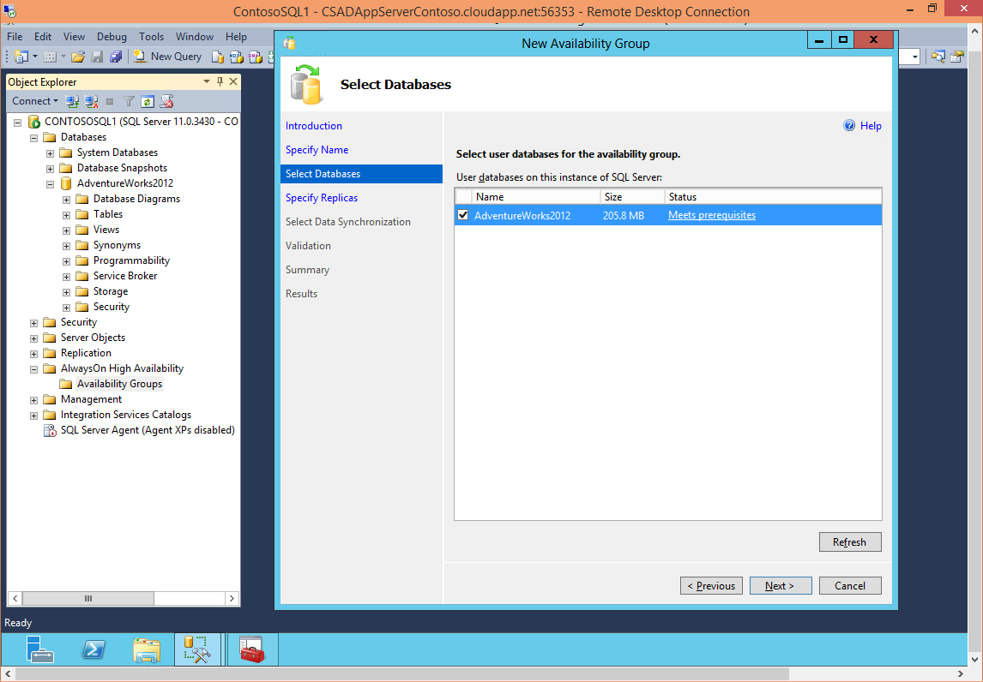

1. In the **Specify Replicas** page, click **Add Replica**.

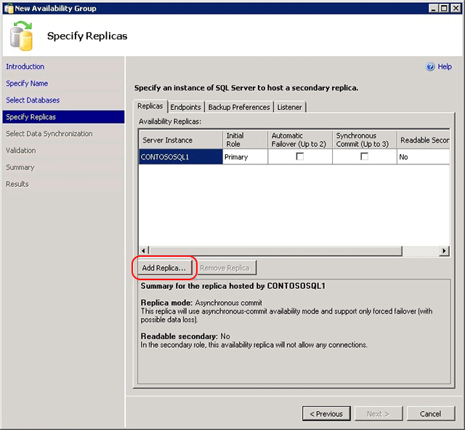

1. The **Connect to Server** dialog pops up. Type **ContosoSQL2** in **Server name**, then click **Connect**.

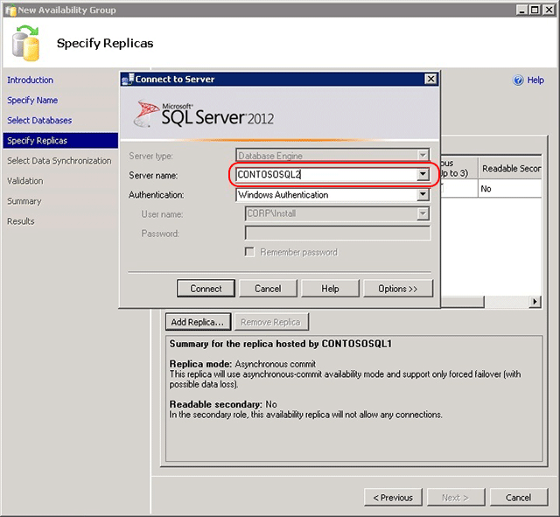

1. Back in the **Specify Replicas** page, you should now see **ContosoSQL2** listed in **Available Replicas**. Configure the replicas as shown below. When you are finished, click **Next**.

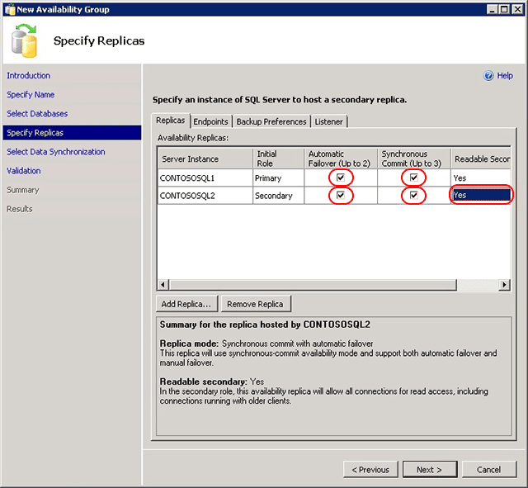

1. In the **Select Initial Data Synchronization** page, select **Join only** and click **Next**. You have already performed data synchronization manually when you took the full and transaction backups on ContosoSQL1 and restored them on ContosoSQL2. You can instead choose not to perform the backup and restore operations on your database and select **Full** to let the New Availability Group Wizard perform data synchronization for you. However, this is not recommended for very large databases that are found in some enterprises.

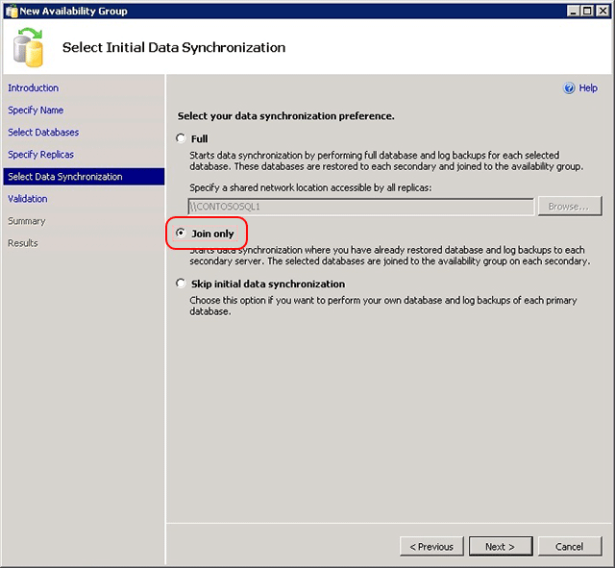

1. In the **Validation** page, click **Next**. This page should look similar to below. There is a warning for the listener configuration because you have not configured an availability group listener. I intentionally skipped that step because availability group listeners are not currently supported in Azure VMs.

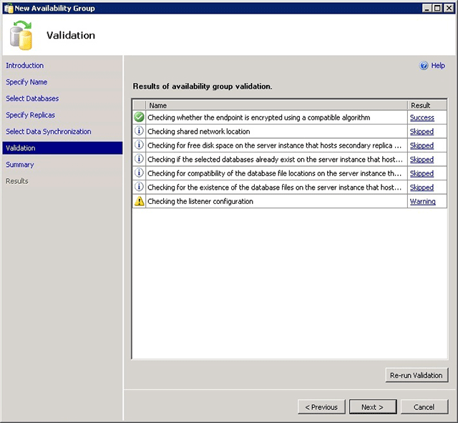

1. In the **Summary** page, click **Finish**, then wait while the wizard configures the new availability group. In the **Progress** page, you can click **More details** to view the detailed progress. Once the wizard is finished, inspect the **Results** page to verify that the availability group is successfully created, as shown below, then click **Close** to exit the wizard.

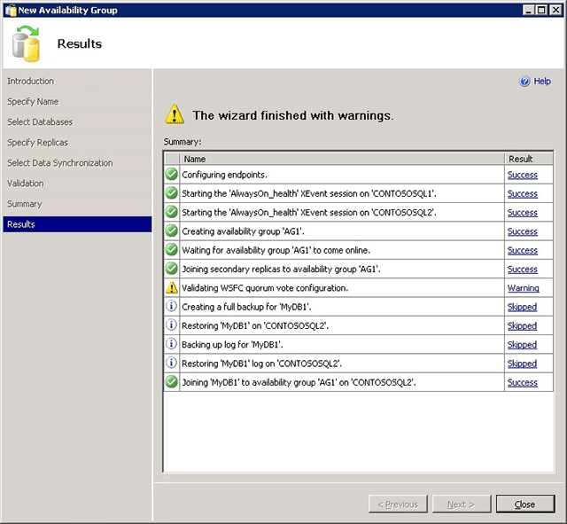

1. In the **Object Explorer**, expand **AlwaysOn High Availability**, then expand **Availability Groups**. You should now see the new availability group in this container. Right-click **AG1 (Primary)** and click **Show Dashboard**.

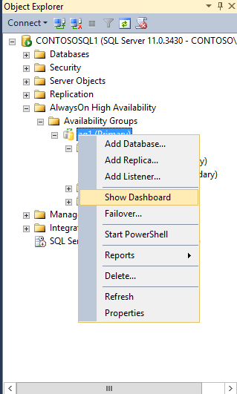

Your AlwaysOn Dashboard should look similar to the one shown below. You can see the replicas, the failover mode of each replica and the synchronization state.

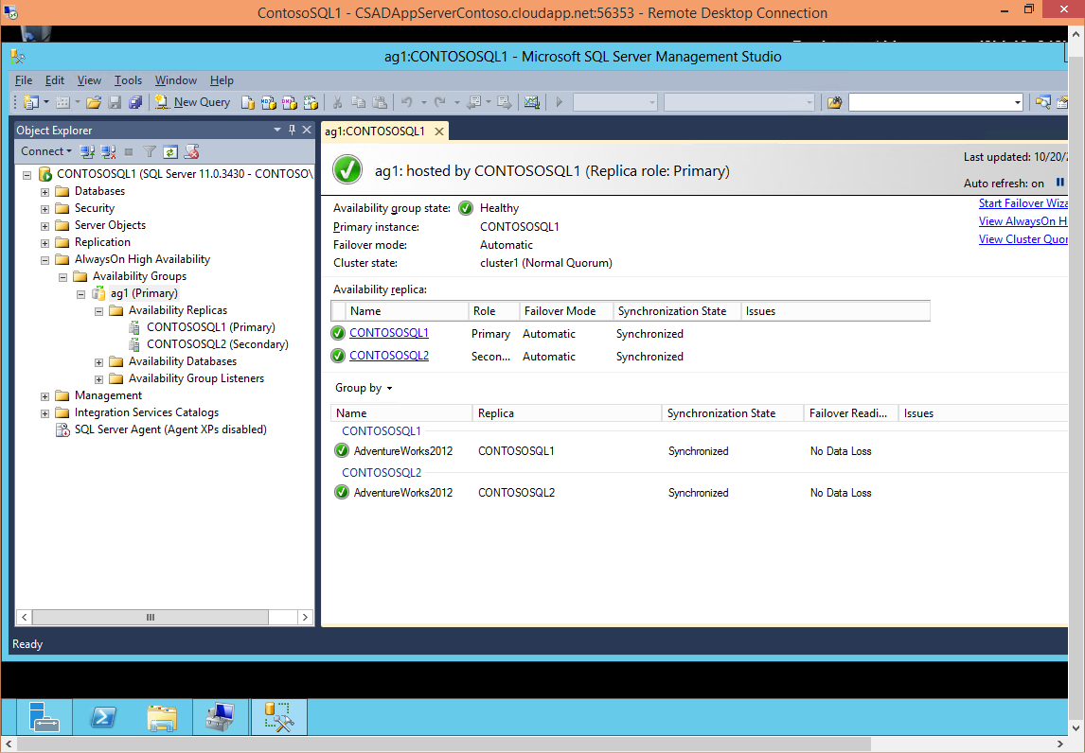

1. From **Administrative Tools**, **Failover Cluster Manager**, then expand **Cluster1.corp.contoso.com**, and then expand **Services and applications**. A new clustered service called **AG1** has been created in **Cluster1** to represent the availability group that you just configured. Note that AG1 does not have any IP address by which database clients can connect to the availability group, because you did not configure one and because that IP address would not work even if you configured it since the Azure virtual network does not support static IP addresses.

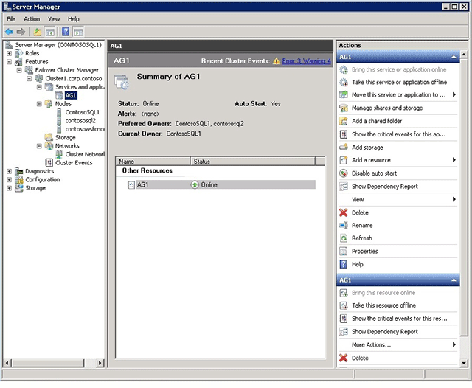

|  |
| --- |
| **WarningWarning** |
| Do not try to fail over this clustered service. All failover operations should be performed from within AlwaysOn Dashboard in SSMS. For more information, see [Restrictions on Using The WSFC Failover Cluster Manager with Availability Groups](http://msdn.microsoft.com/en-us/library/ff929171.aspx) |

You have now successfully implemented SQL Server AlwaysOn by creating an availability group in Azure. To configure a listener for this availability group, see [Tutorial: Listener Configuration for AlwaysOn Availability Groups in Azure](http://msdn.microsoft.com/en-us/library/azure/dn376546.aspx).

#### Task 7 – Listener Configuration for AlwaysOn Availability Groups

Extracted and adapted from [Listener Configuration for AlwaysOn Availability Groups](http://msdn.microsoft.com/en-us/library/azure/dn425027.aspx)

This topic shows you how to configure a listener for an AlwaysOn Availability Group. Your Availability Group can contain replicas that are on-premises only, Azure only, or span both on-premises and Azure for hybrid configurations. Azure replicas can reside within the same region or across multiple regions using multiple virtual networks (VNets).

The steps below assume you have already configured an availability group but have not configured a listener. Note the following limitations on the availability group listener in Azure:

* The availability group listener is supported on Windows Server 2008 R2, Windows Server 2012, and Windows Server 2012 R2.
* The client application must reside on a different cloud service than the one that contains your availability group VMs. Azure does not support direct server return with client and server in the same cloud service.
* Only one availability group listener is supported per cloud service because the listener is configured to use the cloud service IP address.
* If you are creating a listener for a hybrid environment, the on-premises network must have connectivity to the public Internet in addition to the site-to-site VPN with the Azure virtual network. When in the Azure subnet, the availability group listener is reachable only by the public IP address of the respective cloud service.

|  |
| --- |
| **ImportantImportant** |
| On-premises Availability Group listeners can be configured using SQL Server Management Studio (SSMS) graphical user interface, through Transact-SQL, and through PowerShell. However, there is currently no configurable option in the Azure portal for you to enable direct server return (DSR) when creating a listener. This tutorial focuses on using PowerShell to create a listener for an Availability Group that includes Azure replicas. For more information on how to configure listeners using SSMS or Transact-SQL, see [Create or Configure an Availability Group Listener](http://go.microsoft.com/fwlink/?LinkId=393223). |

##### Step 1: Create load-balanced VM endpoints with direct server return in Azure

First, you need to create a load-balanced endpoint for each VM hosting an Azure replica. If you have replicas in multiple regions, each replica for that region must be in the same cloud service in the same VNet. Creating Availability Group replicas that span multiple Azure regions requires configuring multiple VNets. For more information on configuring cross VNet connectivity, see [Configure VNet to VNet Connectivity](http://go.microsoft.com/fwlink/?LinkId=401171).

1. In the Azure portal, navigate to each VM hosting a replica and view the details.
2. Click the **Endpoints** tab for each of the VMs.
3. Verify that the **Name** and **Public Port** of the listener endpoint you want to use is not already in use.
4. On your local client, download and install [Azure PowerShell June 2013 or later](http://www.windowsazure.com/en-us/downloads/).
5. Launch **Azure PowerShell**. A new PowerShell session is opened with the Azure administrative modules loaded.
6. Run Get-AzurePublishSettingsFile. This cmdlet directs you to a browser to download a publish settings file to a local directory. You may be prompted for your log-in credentials for your Azure subscription.
7. Copy the PowerShell script below into a text editor and set the variable values to suit your environment.

Windows PowerShell

Add-AzureAccount

# Define variables

$AGNodes = "<VM1>","<VM2>","<VM3>" # all availability group nodes should be included, separated by commas

$ServiceName = "<MyCloudService>" # the name of the cloud service that contains the availability group nodes

$EndpointName = "<MyEndpoint>" # name of the endpoint

$EndpointPort = "<PortNumber>" # public port to use for the endpoint

# Configure a load balanced endpoint for each node in $AGNodes, with direct server return enabled

ForEach ($node in $AGNodes)

{

Get-AzureVM -ServiceName $ServiceName -Name $node | Add-AzureEndpoint -Name $EndpointName -Protocol "TCP" -PublicPort $EndpointPort -LocalPort $EndpointPort -LBSetName "$EndpointName-LB" -ProbePort 59999 -ProbeProtocol "TCP" -DirectServerReturn $true | Update-AzureVM

}

1. Once you have set the variables, copy the script from the text editor into your Azure PowerShell session to run it. If the prompt still shows >>, type ENTER again to make sure the script starts running.

##### Step 2: Make sure KB2854082 is installed on all Windows Server 2008 R2 and Windows Server 2012 cluster nodes

Next, you need to make sure that the hotfix [KB2854082](http://support.microsoft.com/kb/2854082) is installed on each of the on-premises server or Azure VM that is part of the cluster. Any server or VM that is in the cluster, but not in the availability group, should also have this hotfix installed.

In the remote desktop session for each of the cluster nodes, download [KB2854082](http://support.microsoft.com/kb/2854082) to a local directory. Then, install the hotfix on each of the cluster nodes sequentially. If the cluster service is currently running on the cluster node, the server is restarted at the end of the hotfix installation.

|  |
| --- |
| **WarningWarning** |
| Stopping the cluster service or restarting the server affects the quorum health of your cluster and the availability group, and may cause your cluster to go offline. To maintain the high availability of your cluster during installation, make sure that:   * The cluster is in optimal quorum health, * All cluster nodes are online before installing the hotfix on any node, and * Allow the hotfix installation to run to completion on one node, including fully restarting the server, before installing the hotfix on any other node in the cluster. |

##### Step 3: Open the firewall ports in availability group nodes in Azure

In this step, you create a firewall rule to open the probe port for the load-balanced endpoint (59999 as specified earlier), and another rule to open the availability group listener port. Since you created the load-balanced endpoint on the Azure VMs that contain availability group replicas, you need to open the probe port and the listener port on the respective Azure VMs.

1. On VM hosting a replica, launch **Windows Firewall with Advanced Security**.
2. Right-click **Inbound Rules** and click **New Rule**.
3. In the **Rule Type** page, select **Port**, then click **Next**.
4. In the **Protocol and Ports** page, select **TCP** and type **59999** in the **Specific local ports** box. Then, click **Next**.
5. In the **Action** page, keep **Allow the connection** selected and click **Next**.
6. In the **Profile** page, accept the default settings and click **Next**.
7. In the **Name** page, specify a rule name, such as **AlwaysOn Listener Probe Port** in the **Name** text box, and click **Finish**.
8. Repeat the above steps for the availability group listener port (as specified earlier in the $EndpointPort parameter) and specify an appropriate rule name, such as **AlwaysOn Listener Port**.

##### Step 4: Create the availability group listener

In this step, you manually create the availability group listener in Failover Cluster Manager and SQL Server Management Studio (SSMS).

1. Open Failover Cluster Manager from the node hosting the primary replica.
2. Expand the cluster name, then click **Roles**.
3. In the **Roles** pane, right-click the availability group name and then select **Add Resource** > **Client Access Point**.

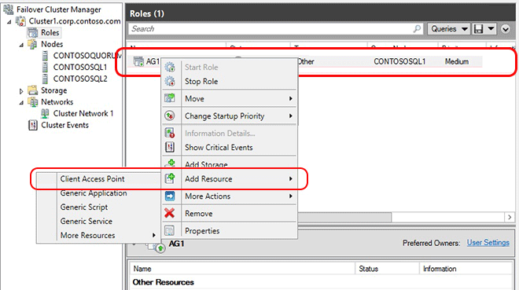

1. In the **Name** box, type the desired listener name, then click **Next** twice, and then click **Finish**.
2. Click the **Resources** tab, then expand the Client Access Point you just created. You will see the IP address resource for each of the cluster networks in your cluster.
3. If you are configuring a hybrid solution, continue with this step. If you are configuring an Azure only solution, skip to the next step.
   1. Right-click the IP Address resource that corresponds to your on-premises subnet, then select **Properties**. Note the IP Address Name and the Network Name.
   2. Select **Static IP Address**, assign an unused IP address and then click **OK**.
4. Right-click the IP resource that corresponds to your Azure subnet and then select **Properties**. Note the IP Address Name and the Network Name. Repeat this step for each IP resource if your solution spans multiple Azure VNets.
5. Log into the Azure portal. Navigate to the cloud service that contains your availability group VM. Open the **Dashboard** view. Note the address shown under **Public Virtual IP (VIP) Address**. Repeat this step for each cloud service that contains a VM that hosts an availability replica in this solution.
6. On each Azure VM, copy the PowerShell script below into a text editor and set the variables to the values you noted earlier. Make sure to enter the values specific for the subnet for the VM you are working on.

Windows PowerShell

Add-AzureAccount

# Define variables

$ClusterNetworkName = "<ClusterNetworkName>" # the cluster network name

$IPResourceName = "<IPResourceName>" # the IP Address resource name

$CloudServiceIP = "X.X.X.X" # IP address of your cloud service

Import-Module FailoverClusters

# If you are using Windows 2012 or higher, use the Get-Cluster Resource command. If you are using Windows 2008 R2, use the cluster res command. Both commands are commented out. Choose the one applicable to your environment and remove the # at the beginning of the line to convert the comment to an executable line of code.

# Get-ClusterResource $IPResourceName | Set-ClusterParameter -Multiple @{"Address"="$CloudServiceIP";"ProbePort"="59999";SubnetMask="255.255.255.255";"Network"="$ClusterNetworkName";"OverrideAddressMatch"=1;"EnableDhcp"=0}

# cluster res $IPResourceName /priv enabledhcp=0 overrideaddressmatch=1 address=$CloudServiceIP probeport=59999  subnetmask=255.255.255.255

1. Once you have set the variables, open an elevated Windows PowerShell window, then copy the script from the text editor and paste into your Azure PowerShell session to run it. If the prompt still shows >>, type ENTER again to make sure the script starts running. Repeat this on each VM.

This script configures the IP Address resource with the IP address of the cloud service and sets other parameters like the probe port. When the IP Address resource is brought online, it can then respond to the polling on the probe port from the load-balanced endpoint created earlier in this tutorial.

1. Navigate back to Failover Cluster Manager. Expand **Roles** and then highlight your Availability Group. On the **Resources** tab, right-click the listener name and click **Properties**.
2. Click the **Dependencies** tab, verify the IP addresses have OR, not AND, dependencies. Click **OK**.
3. Right-click the listener name and click **Bring Online** .
4. Once the listener is online, from the **Resources** tab, right-click the availability group and click **Properties**.

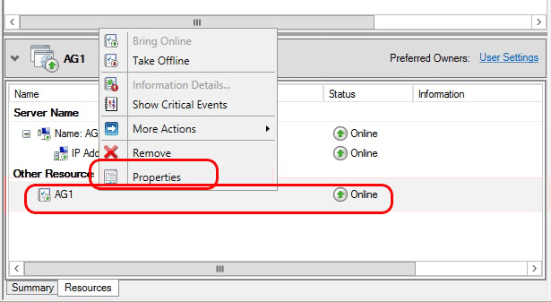

1. Create a dependency on the listener name resource.

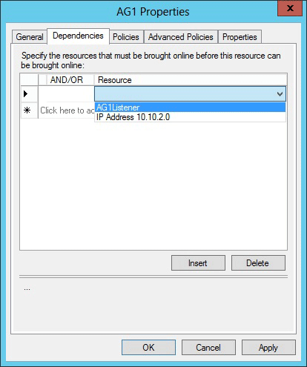

1. Launch SQL Server Management Studio and connect to the primary replica.
2. Navigate to **AlwaysOn High Availability** > **Availability Groups** > **<AvailabilityGroupName>** > **Availability Group Listeners**. You should now see the listener name that you created in **Failover Cluster Manager**. Right-click the listener name and click **Properties**.
3. In the **Port** box, specify the port number for the availability group listener by using the $EndpointPort you used earlier, then click **OK**.

##### Step 5: Follow-up after creating the availability group listener

After the availability group listener is created, it may be necessary to adjust the RegisterAllProvidersIP and HostRecordTTL cluster parameters for the listener resource. These parameters may reduce reconnection time after a failover which may prevent connection timeouts. For more information on these parameters, as well as sample code, see [Create or Configure an Availability Group Listener](http://msdn.microsoft.com/en-us/library/hh213080.aspx#MultiSubnetFailover).

##### Step 6: Test the availability group listener

In this step, you test the availability group listener using a client application. An easy way to complete this test is to try to connect SSMS to the availability group listener. Another simple method is to run [SQLCMD.exe](http://technet.microsoft.com/en-us/library/ms162773.aspx) as follows:

VB

sqlcmd –S "<ListenerName>,<EndpointPort>" -d "<DatabaseName>" -Q "select @@servername, db_name()" -l 15

When testing the listener, be sure to fail over the availability group to make sure that clients can connect to the listener across failovers.

### Exercise 6: Deploying a Simple MVC4 Application - Manually

In this exercise, you will learn how to deploy a simple ASP.NET MVC4 application in the IIS of the Azure Virtual Machine you have previously configured.

**Note:** To make this solution highly available, you need to configure the SQL Servers in an availability set and set up SQL Server Mirroring between the instances.

#### Task 1 - Deploying a Simple MVC4 Application

In this task, you will deploy the MVC4 application to the IIS Virtual Machines.

1. In the Azure Portal, Click **Virtual Machines** on the left menu.
2. You will see a list with your existing Virtual Machines. Select the first one you created in Exercise 1 and click **Connect**. If you used the proposed name, this Virtual Machine's should be named **iisvm1**.
3. You will be prompted to download the remote desktop client. Click **Open** and log on using the Admin credentials you defined when creating the Virtual Machine.
4. In the Server Manager, Local Server, **Internet explorer Enhanced Security** dialog, turn **off** enhanced security for **Administrators** and click **OK**.

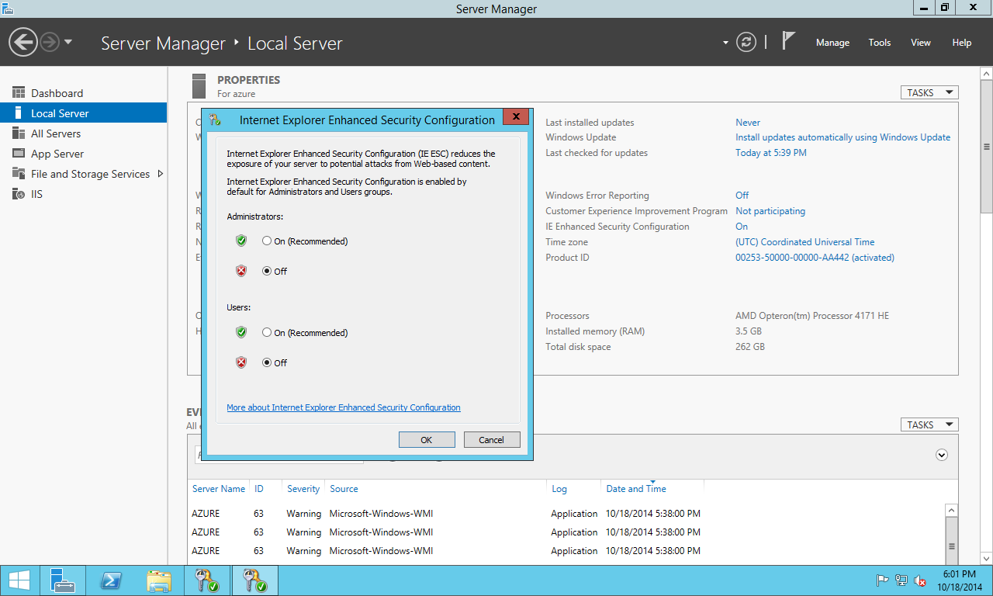

Internet Explorer Enhanced Security

**Note:** Modifying Internet Explorer Enhanced Security configurations is not a good practice and it only for the purpose of this particular lab. The correct approach would be to download the files locally and then copy them to a shared folder or directly to the Virtual Machine.

1. Once **.Net Framework 4.5** installation finishes, open **wwwroot** folder located at **C:\inetpub\** and copy the file **7 - Hand On Lab - Dev Test StarterKit.zip** located in the **current** **folder** of this lab. To do this, copy **7 - Hand On Lab - Dev Test StarterKit.zip** (**Ctrl + C**) and paste it (**Ctrl + V**) in the Virtual Machine's **wwwroot** folder. Extract all files to **C:\inetpub\wwwroot\CloudShop** folder.

[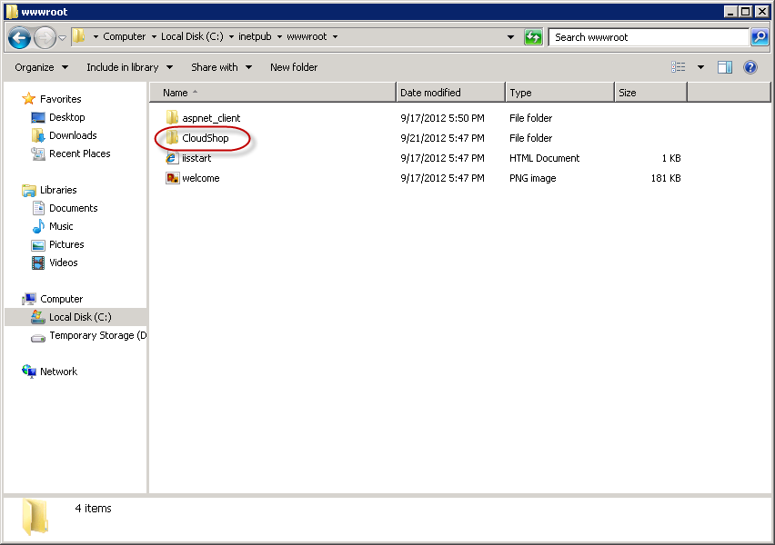](https://github.com/WindowsAzure-TrainingKit/HOL-IntroToWindowsAzureVirtualMachines/blob/master/Images/wwwroot-folder.png?raw=true)

wwwroot folder

1. Open with **Notepad** the **Web.config** file located in **C:\inetpub\wwwroot\CloudShop**. Replace the connection strings placeholder with the name of your SQL Server (by default, is the Virtual Machine's name).
2. <connectionStrings>
3. <add name="AdventureWorksEntities" connectionString="metadata=res://*/Models.AdventureWorks.csdl|res://*/Models.AdventureWorks.ssdl|res://*/Models.AdventureWorks.msl;provider=System.Data.SqlClient;provider connection string=&quot;data source=["<ListenerName>,<EndpointPort];initial catalog=AdventureWorks2012;Uid=CloudShop;Password=Azure$123;multipleactiveresultsets=True;App=EntityFramework&quot;" providerName="System.Data.EntityClient" />
4. <add name="DefaultConnection" connectionString="Data Source=["<ListenerName>,<EndpointPort];initial catalog=AdventureWorks2012;Uid=CloudShop;Password=Azure$123;MultipleActiveResultSets=True" providerName="System.Data.SqlClient" />
5. </connectionStrings>
6. Open the **Internet Information Services (IIS) Manager** from **Start | Administrative Tools**.
7. In the **Connections** pane, expand **Default Web Site** within your IIS Server's node. You will see the **CloudShop** folder you copied in the **wwwroot** folder.

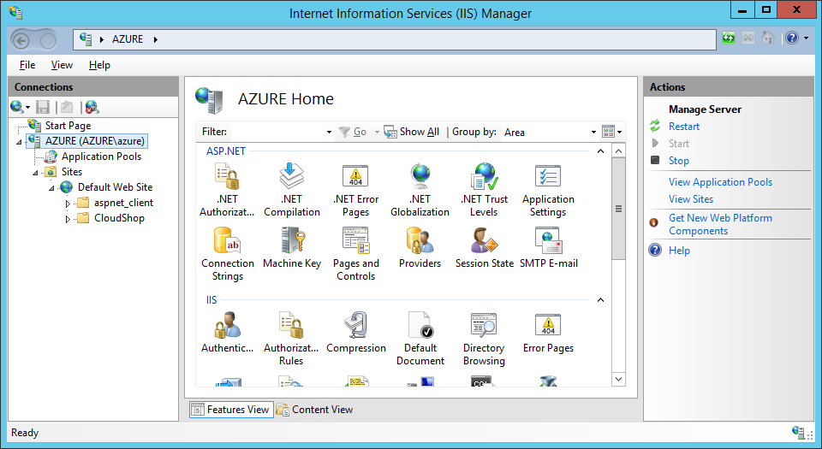

IIS Manager

1. Right-click **CloudShop** folder and select **Convert to Application**.

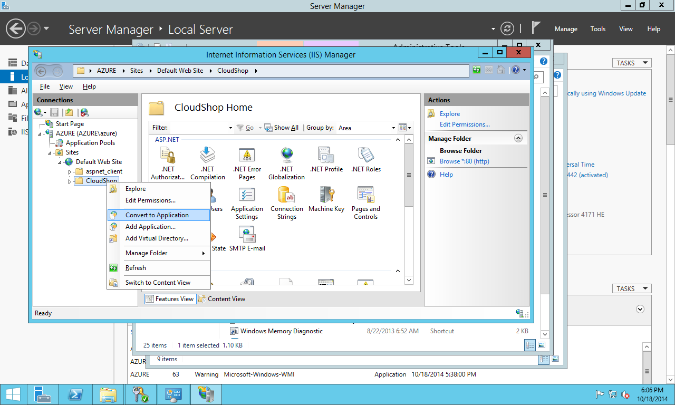

IIS Manager - Convert to Application

1. In the **Add Application** dialog, Change the Application Pool to **ASP.Net v4.0** **OK**.

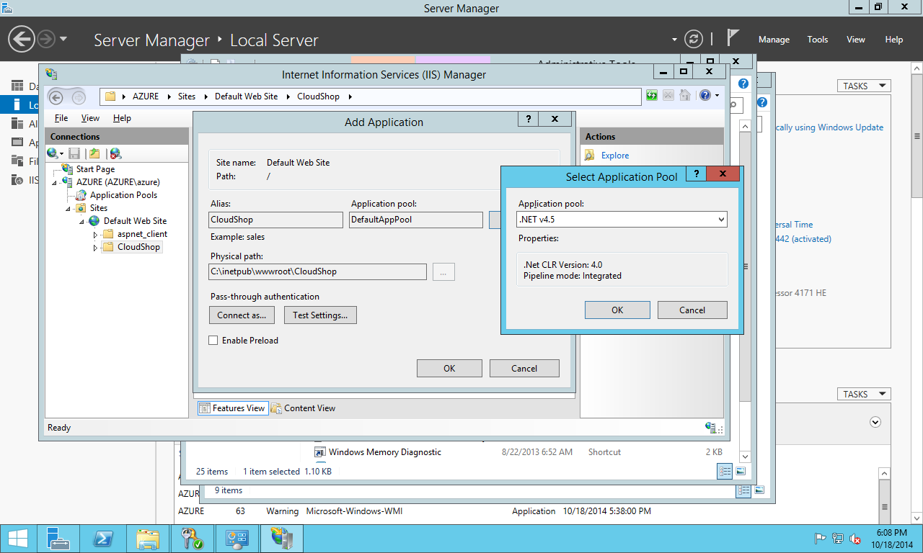

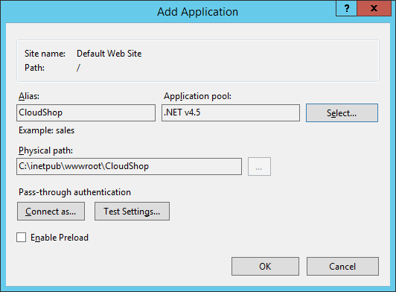

Add Application dialog

1. Close the **Internet Information Server (IIS) Manager** window.
2. Close the **Remote Desktop Connection**.
3. Repeat this task in the second Virtual Machine you created in **Exercise 1 -Task 1**. If you used the proposed name, this Virtual Machine should be named **iisvm2**.

#### Verification

In this task, you will test the Cloud Shop MVC4 application you deployed in the previous task.

1. In your local machine, open **Internet Explorer**.
2. Go to http://[**YOUR-SERVICE-NAME**].cloudapp.net/CloudShop. The Service Name is the one you used when creating the IIS Virtual Machines (you can also check it in the Azure Portal, within Virtual Machine's dashboard).

[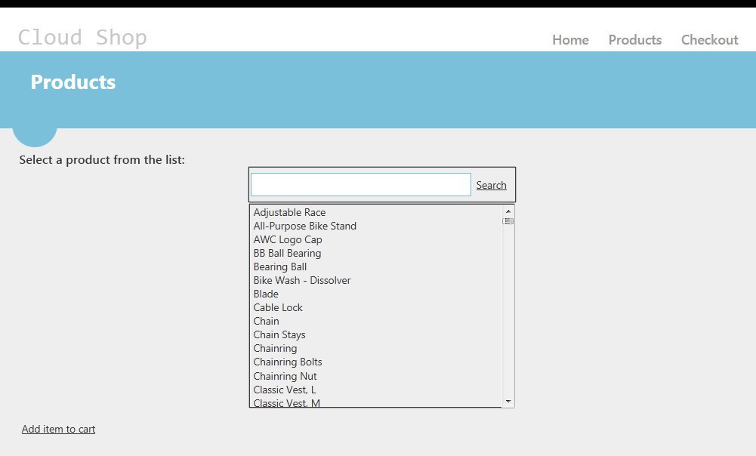](https://github.com/WindowsAzure-TrainingKit/HOL-IntroToWindowsAzureVirtualMachines/blob/master/Images/MVC4-Application-running-in-the-Web-Farm.png?raw=true)

MVC4 Application running in the Web Farm

1. In the **Search** box, write Classic and click **Search**. It will show all the products that have a product name that match the search criteria.

[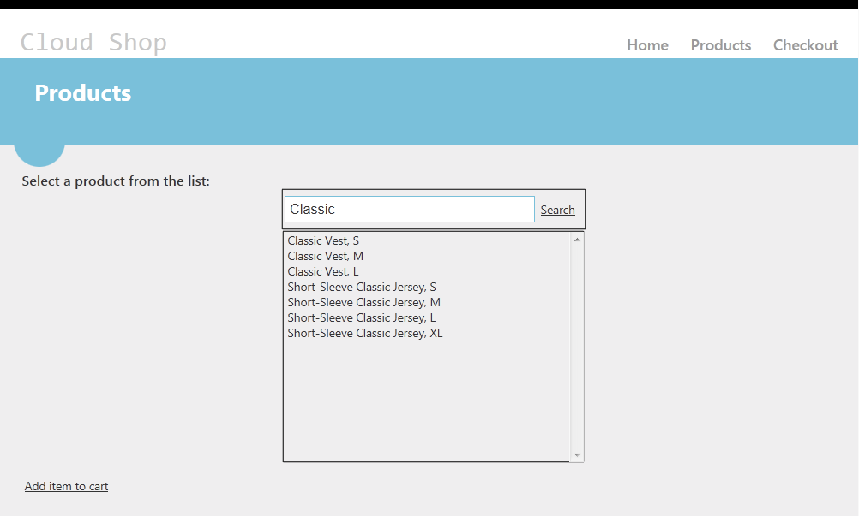](https://github.com/WindowsAzure-TrainingKit/HOL-IntroToWindowsAzureVirtualMachines/blob/master/Images/searching-products2.png?raw=true)

Searching Products

### Exercise 7: Provisioning Automation with Custom Images and PowerShell

1. Microsoft Azure Virtual Machines allow you to customize a virtual machine by installing software or making configuration changes and then saving the result as a generalized image. In this part you will generalize a customized Windows virtual machine and capture it as an image. You will then create multiple identical virtual machines from the same image.
2. RDP into **iisvm2** and click **Start -> Run**. Type in sysprep and press **ENTER**.
3. In the opened window, right-click on sysprep.exe and select **Run as administrator**.

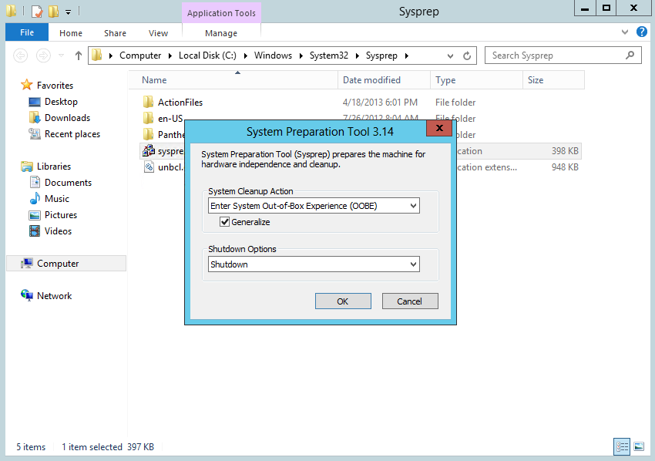

1. Select **Enter System Out-of-Box Experience (OOBE)**, check **Generalize** and select **Shutdown**.
2. Press **OK** and wait for the virtual machine to show the **Stopped** status in the Microsoft Azure Management portal.

**Note**: It takes from 5 to 10 minutes to stop the virtual machine.

1. Highlight the virtual machine and press the **Capture** button in the toolbar.

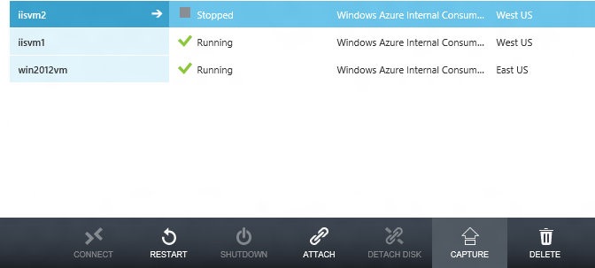

1. When the capture dialog appears, name the new image **webappimg** and check **I have run sysprep in the virtual machine**.

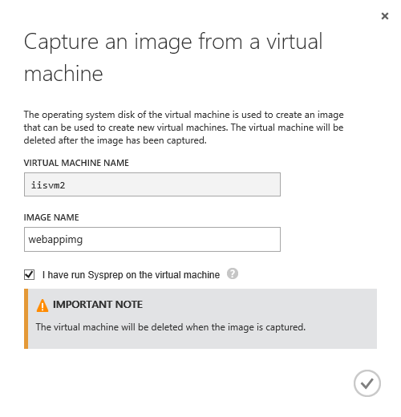

1. Once the virtual machine has completed capturing, note that iisvm2 is no longer listed and show the available images by clicking **Images** on the virtual machine's listing page.

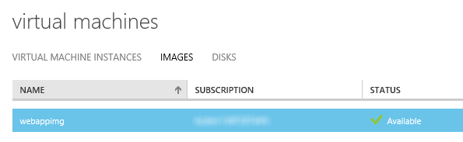

1. The final step of the demo is to show how to create multiple virtual machines from the image. Paste in and run the following powershell script to create three identical virtual machines using the image name.

PowerShell

Add-AzureAccount

Select-AzureSubscription -SubscriptionName '[SUBSCRIPTION-NAME]'

$adminUser = "[ADMIN-USER]"

$adminPassword = "[ADMIN-PWD]"

$cloudService = '[CLOUD SERVICE-NAME – CREATED ON EXERCISE 1]'

$vnet = '[VIRTUAL NETWORK NAME]'  
$afgroup = '[AFFINITY GROUP NAME]'

$iisvm2 = New-AzureVMConfig -Name 'iisvm2' -InstanceSize Medium -ImageName 'webappimg' -AvailabilitySetName 'avsetappserver' | Set-AzureSubnet "SubnetApp” |

Add-AzureEndpoint -Name http -LocalPort 80 -PublicPort 80 -Protocol tcp -LBSetName webport -ProbePath '/' -ProbeProtocol tcp -ProbePort 80 |

Add-AzureProvisioningConfig -Windows -AdminUserName $adminUser -Password $adminPassword

$iisvm3 = New-AzureVMConfig -Name 'iisvm3' -InstanceSize Medium -ImageName 'webappimg' -AvailabilitySetName 'avsetappserver' | Set-AzureSubnet "SubnetApp” |

Add-AzureEndpoint -Name http -LocalPort 80 -PublicPort 80 -Protocol tcp -LBSetName webport -ProbePath '/' -ProbeProtocol tcp -ProbePort 80 |

Add-AzureProvisioningConfig -Windows -AdminUserName $adminUser -Password $adminPassword

$iisvm4 = New-AzureVMConfig -Name 'iisvm4' -InstanceSize Medium -ImageName 'webappimg' -AvailabilitySetName 'avsetappserver' | Set-AzureSubnet "SubnetApp” |

Add-AzureEndpoint -Name http -LocalPort 80 -PublicPort 80 -Protocol tcp -LBSetName webport -ProbePath '/' -ProbeProtocol tcp -ProbePort 80 |

Add-AzureProvisioningConfig -Windows -AdminUserName $adminUser -Password $adminPassword

New-AzureVM -ServiceName $cloudService –AffinityGroup $afgroup $affinitygroup -VnetName $vnet -VMs $iisvm2, $iisvm3, $iisvm4

**Note:** Ensure to replace the subscription name and storage account name with the ones where the image was stored..

1. The three virtual machines based on the image will be created. You can see them in the virtual machines view of the management portal.

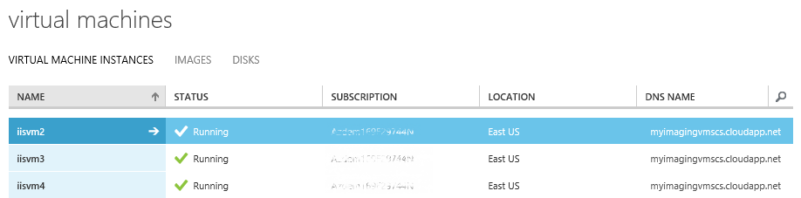

### Exercise 8: Enabling Auto Scaling

* On the Scale page of the Azure Management Portal, you can manually scale your application or you can set parameters to automatically scale it. You can scale applications that are running Web Roles, Worker Roles, or Virtual Machines. To scale an application that is running instances of Web Roles or Worker Roles, you add or remove role instances to accommodate the work load.
* The Virtual Machines that you add can be initially turned on or turned off, but they will be turned on in a scale-up action and turned off in a scale-down action.
* You can only scale an application within the **limit of cores for your subscription**. For example, if your subscription has a limit of twenty cores and you run an application with two medium sized Virtual Machines (a total of four cores), you can only scale up other cloud service deployments in your subscription by sixteen cores. **All Virtual Machines in an availability** **set** that are used in **scaling an application must be the same size**.

On the Scale page, you can configure your cloud service to automatically increase or decrease the number of instances or Virtual Machines that are used by your application. You can configure scaling based on the following parameters:

* [Average CPU usage](http://azure.microsoft.com/en-us/documentation/articles/cloud-services-how-to-scale/#averagecpu) - If the average percentage of CPU usage goes above or below specified thresholds, role instances are created or deleted, or Virtual Machines are are turned on or turned off from an availability set.
* [Queue messages](http://azure.microsoft.com/en-us/documentation/articles/cloud-services-how-to-scale/#queuemessages) - If the number of messages in a queue goes above or below a specified threshold, role instances are created or deleted, or Virtual Machines are are turned on or turned off from an availability set.

#### Task – Auto Scaling by CPU usage

1. In the [Management Portal](https://manage.windowsazure.com/), click **Cloud Services**, and then click the name of the cloud service to open the dashboard.
2. Click **Scale**.
3. Scroll to the section for the role or availability set, and then click **CPU**. This enables automatic scaling of your application based on the average percentage of CPU resources that it uses.

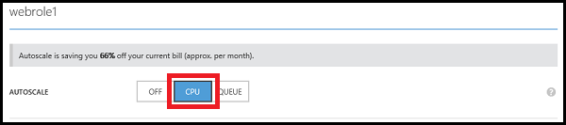

1. Each role or availability set has a slider for changing the number of instances that can be used. To set the maximum number of instances that can be used, drag the bar on the right to the right. To set the minimum number of instances that can be used, drag the bar on the left to the left.

**Note:** On the Scale page, **Instance** represents either a role instance or an instance of a Virtual Machine.

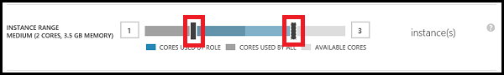

The maximum number of instances is limited by the cores that are available in the subscription. The colors of the slider represent the used and available cores in your subscription:

* Blue represents the maximum number of cores that the role can use.
* Dark grey represents the cores that are used by all roles and Virtual Machines in the subscription. When this value overlaps the cores used by the role, the color turns to dark blue.
* Light grey represents the cores that are available to use for scaling.
* Pink represents a change has been made that has not been saved.

1. A slider is used for specifying the range of average percentage of CPU usage. When the average percentage of CPU usage goes above the maximum setting, more role instances are created or Virtual Machines are turned on. When the average percentage of CPU usage goes below the minimum setting, role instances are deleted or Virtual Machines are turned off. To set the maximum average CPU percentage, drag the bar on the right to the right. To set the minimum average CPU percentage, drag the bar on the left to the left.

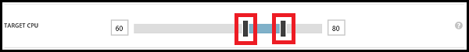

1. You can specify the number of instances to add or turn on each time your application is scaled up. To increase the number of instances that are created or turned on when your application is scaled up, drag the bar right. To decrease the number, drag the bar left.



1. Set the number of minutes to wait between the last scaling action and the next scale-up action. The last scaling action can be either scale-up or scale-down.



All instances are included when calculating the average percentage of CPU usage and the average is based on use over the previous hour. Depending on the number of instances that your application is using, it can take longer than the specified wait time for the scale action to occur if the wait time is set very low. The minimum time between scaling actions is five minutes. Scaling actions cannot occur if any of the instances are in a transitioning state.

1. You can also specify the number of instances to delete or turn off when your application is scaled down. To increase the number of instances that are deleted or turned off when your application is scaled down, drag the bar right. To decrease the number, drag the bar left.



If your application can have sudden increases in CPU usage, you must make sure that you have a sufficient minimum number of instances to handle them.

1. Set the number of minutes to wait between the last scaling action and the next scale-down action. The last scaling action can be either scale-up or scale-down.



1. Click **Save**. The scaling action can take up to five minutes to finish.

## Summary

In this hands-on Lab, you have learnt how to deploy a simple ASP.NET MVC 4 Web application to a Web server hosted in Microsoft Azure, using SQL Server and configuring load balancing. Finally, you automated the deployment with PowerShell and enabled auto scaling for the application.

## Additional References:

* [Enterprise Library - Auto scaling and Microsoft Azure](http://msdn.microsoft.com/en-us/library/hh680945(v=PandP.50).aspx)
* [How to scale a cloud service](http://azure.microsoft.com/en-us/documentation/articles/cloud-services-how-to-scale/)
* [Using Windows PowerShell Scripts to Publish to Dev and Test Environments](http://msdn.microsoft.com/en-us/library/azure/dn642480.aspx#BK_CustomBuild)
* [Imaging Virtual Machines](https://github.com/Azure-Readiness/MicrosoftAzureTrainingKit/blob/master/Demos/Demo-ImagingVMs/Demo.md)